Genetic Algorithm

GA implementation
Correct implementation of all parts of the GA algorithm.

GA results & plots
The plots should demonstrate proper searching and convergence behavior.

Plot the average and the highest fitness score of the population versus the generation of the population.

Select the vector with the highest fitness score in the last generation of the population. Report the hyperparameters.

Train the model on the training and validation data using the selected hyperparameters. Plot the training F1 score versus the training epochs.

Evaluate the model on the test data. Report the test F1 score.
In what follows the following abbreviations refer to:
- E Number of Epochs
- M mutation probability
- S number of new children in each generation which is also equal to the number
- P population size
- I max number of iterations
- Lr learning rate
Note that some codes were interrupted because of service. Some code reached their maximum iterations. And some code had a preset convergence criteria that wasn’t optimal, so it led to early stopping.
However, my main convergence criteria are the max iterations or the condition that avg_fitness becomes more than 0.95 or the max_fitness becomes more than 0.99. Different convergence criteria an be set.
Please note that initially I tested one model, and realized that lr=0.01 is the best value for the learning rate, so I tested most runs with it. Regarding the E value, about 500-600 is best, however it takes so much computation time, so I tested with fewer E values.

Run A
E= 100, M=0.2, I=10,000, S=14, P=30, lr=0.01
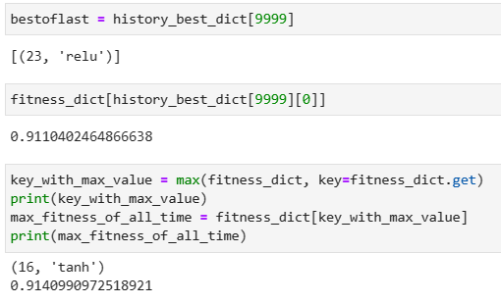
- Best hyperparameters of the last generation = (23, ‘relu’)

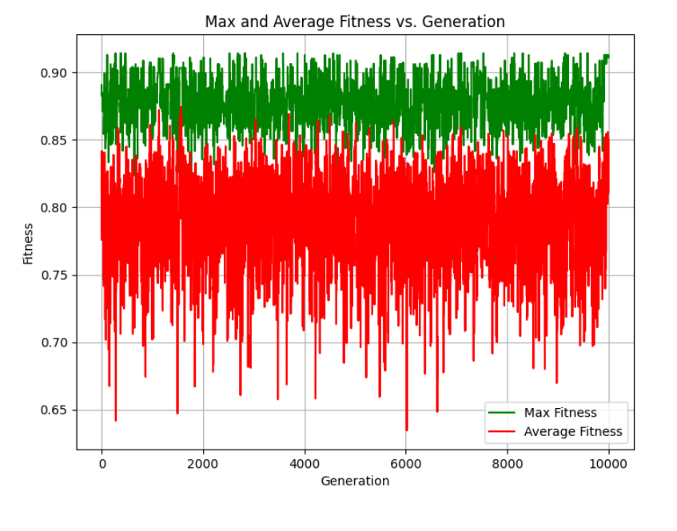
The plots below are of the training on the model using (23, ‘relu’), with E=100, lr=0.01.
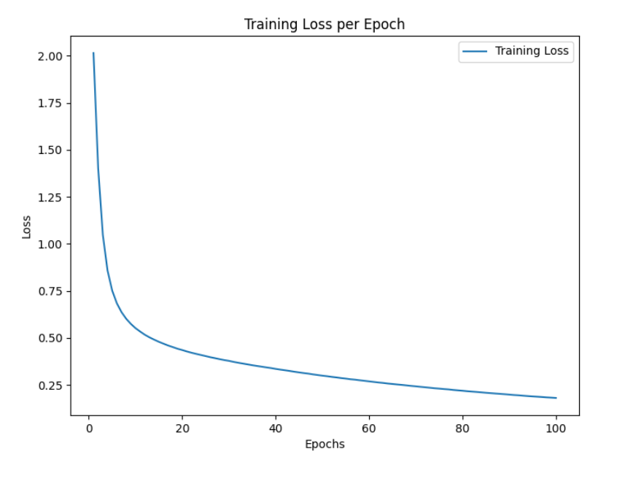
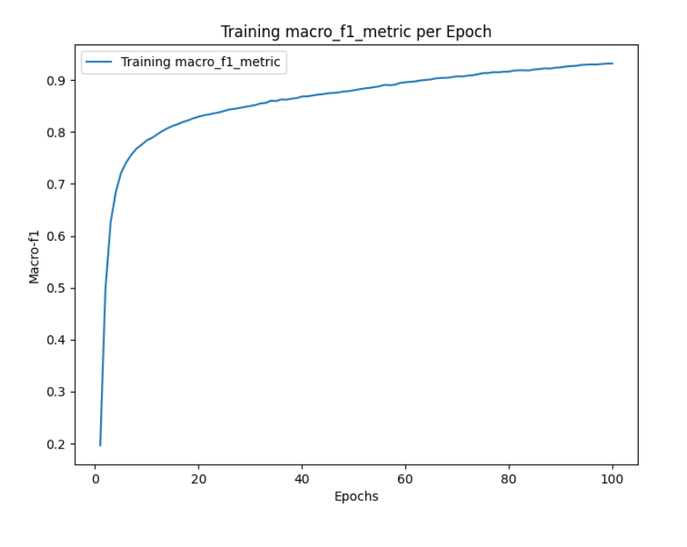

The plots below are of the training on the model using (23, ‘relu’), with E=500, lr=0.01.
(Note that I tested lr=0.001, 0.0001, and 0.01, and found out that lr=0.01 is best).
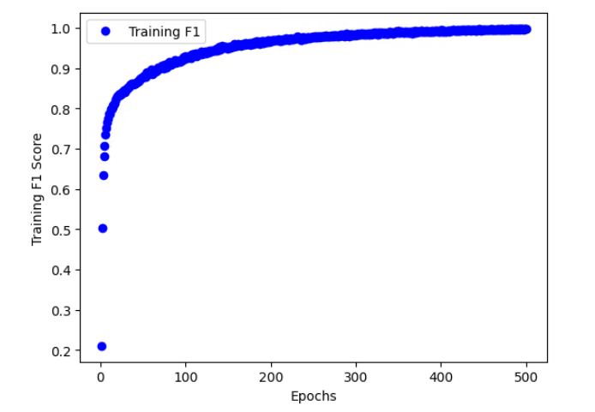
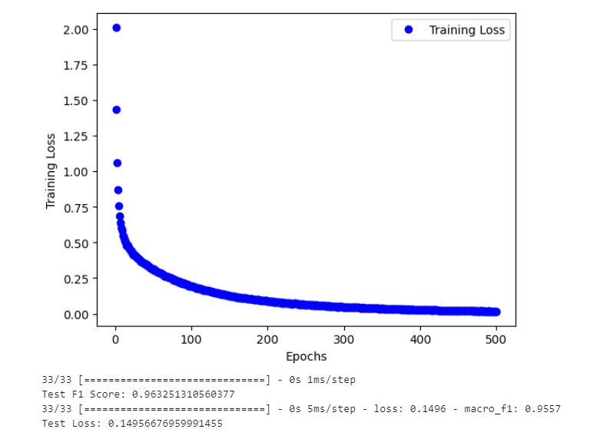

Run B
E=300, I=1000, M=0.15, S=10, P=30, lr=0.01

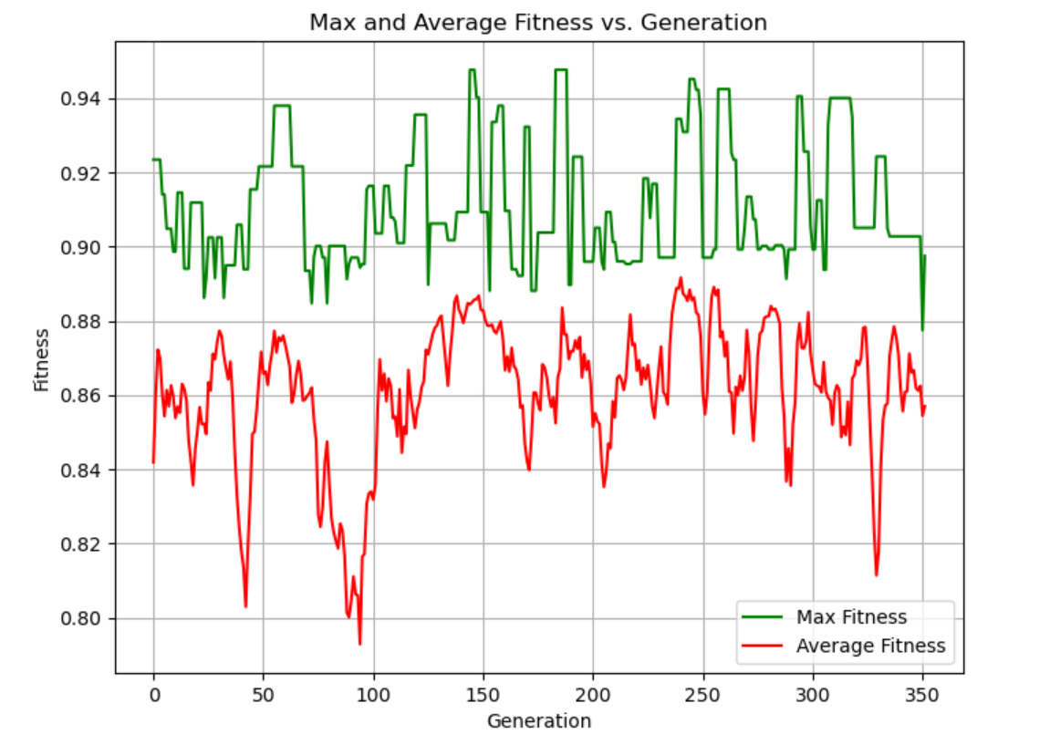
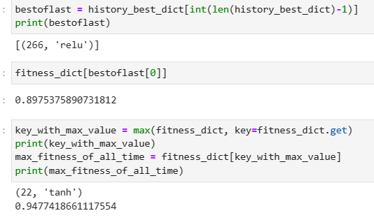
Since the model didn’t converge, instead of looking at the last best chromosome of the last generation, which is (266,’relu’), we will look at (22, tanh).
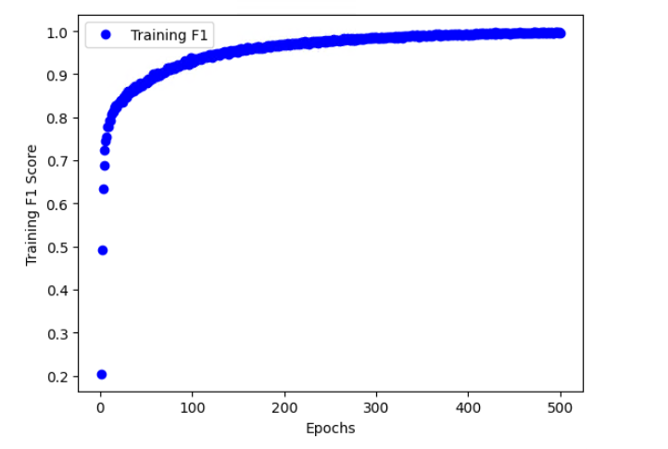
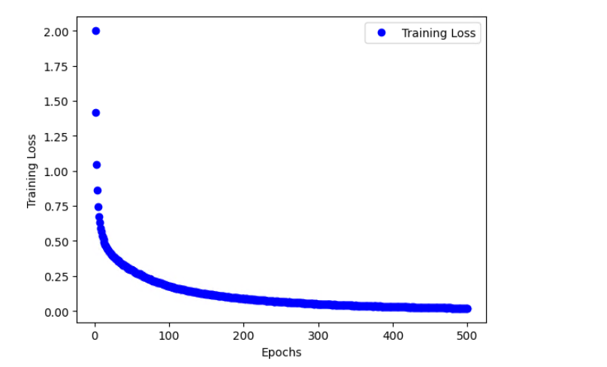
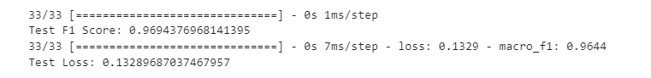
(Tested with E=500, and lr=0.01)

Run C
E=50, 500 generations, m=0.24, S=20, P=40, lr=0.001
- Best hyperparameters of the last generation = 23, ‘relu’
- Combined-training-macro-f1 = 0.8002
- Test-macro-f1=0.799, test-loss=0.5559
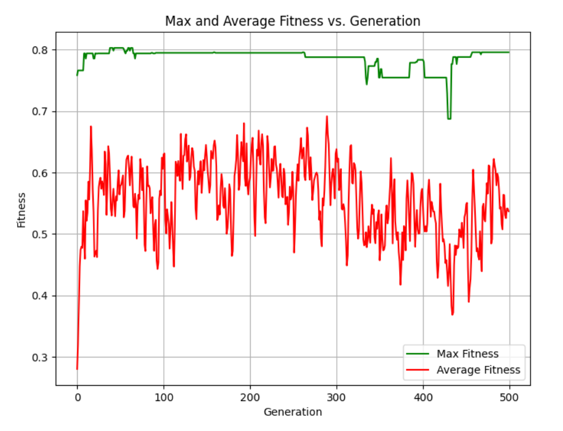
The plots below when tested with E=50, and lr=0.001.
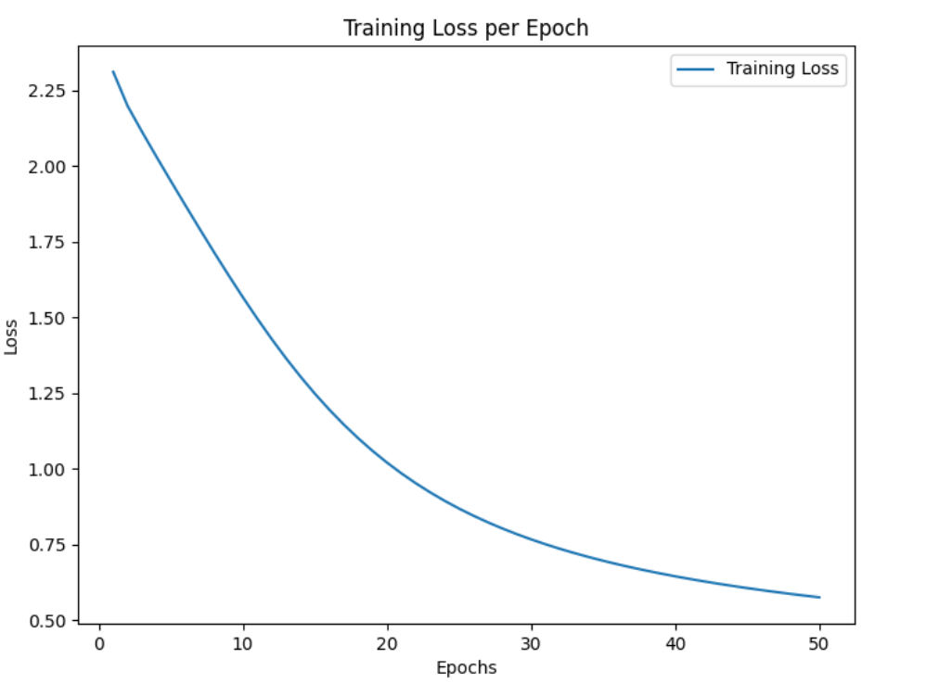
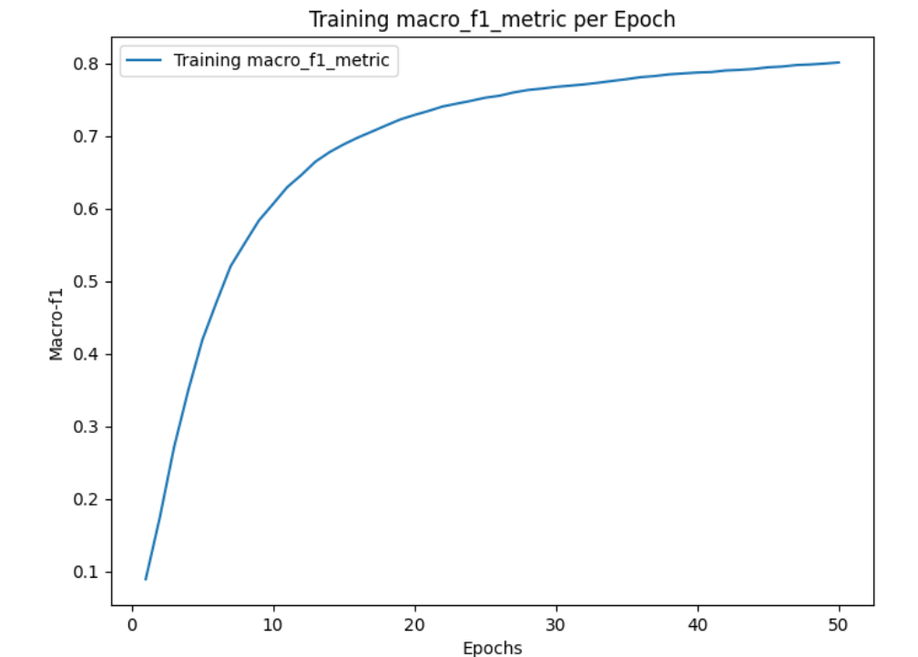

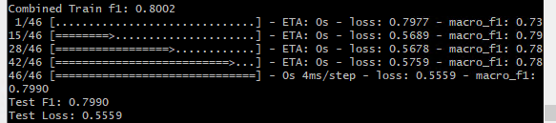
However, if we increase E=500 and lr to 0.01:
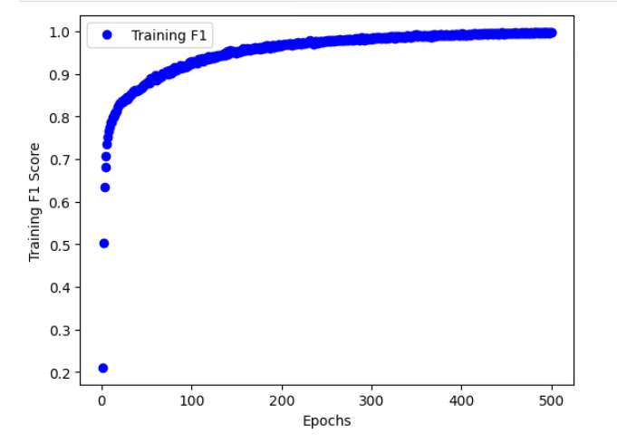
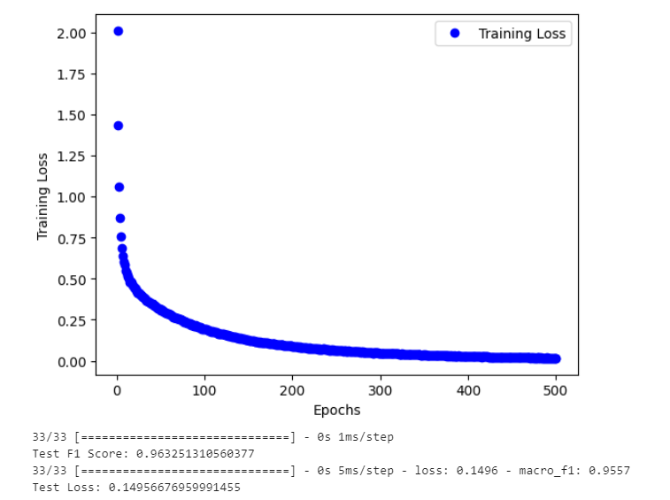

Run D
E=20, 1000 generations, m=0.15, S=8, P=15, lr=0.01

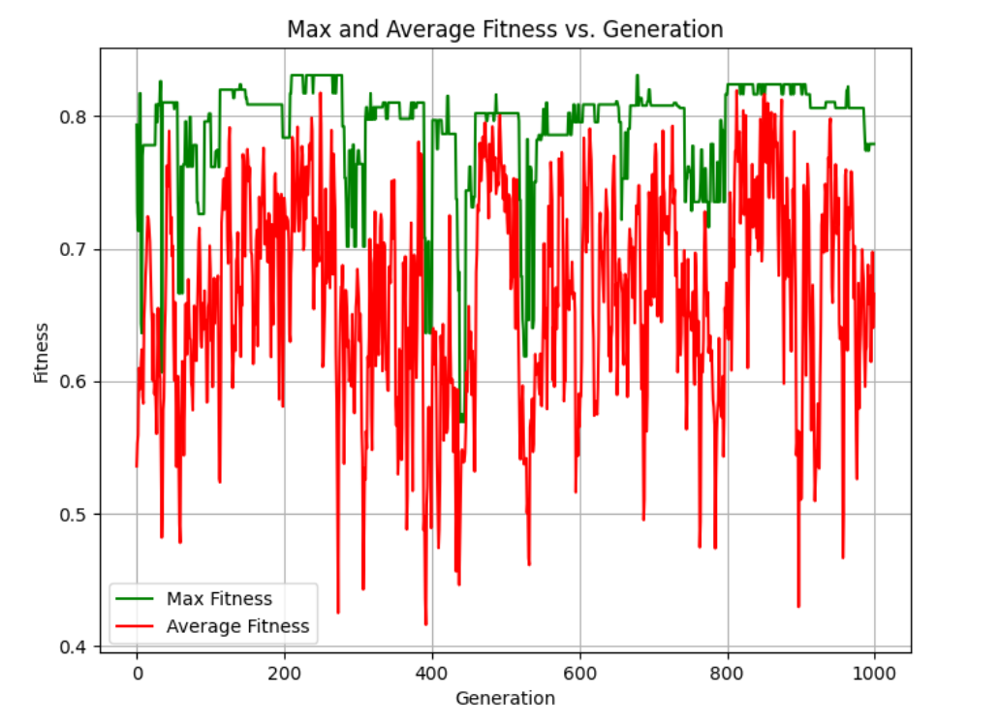
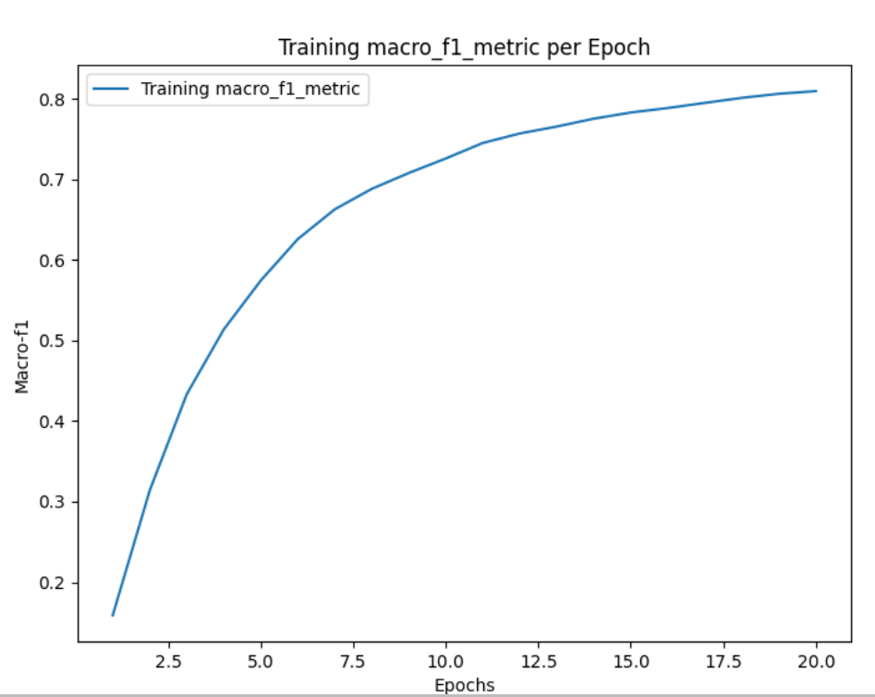
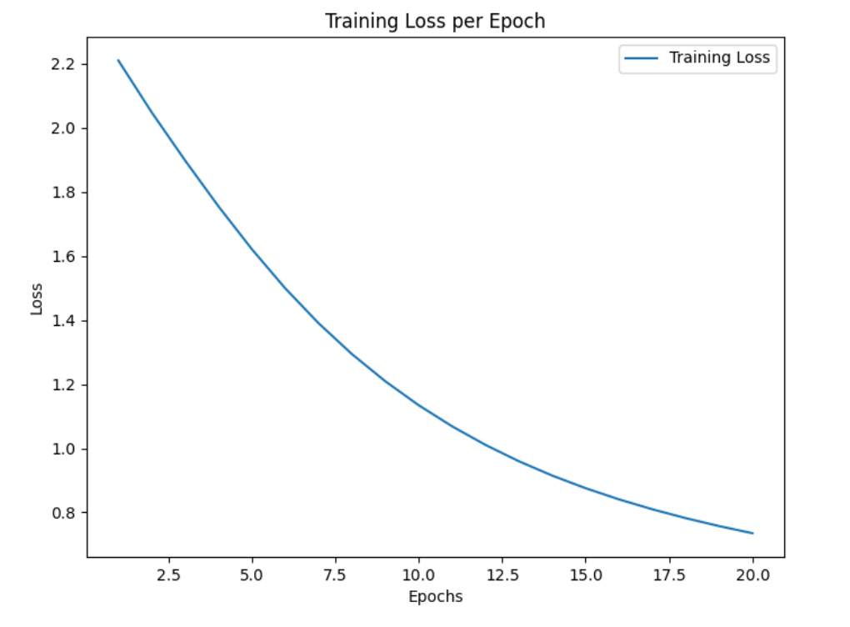
- Best hyperparameters of the last generation = 134, ‘tanh’
- Training the model with the best hyperparameters: train_f1 = 0.7394, train_loss=0.738
- Test-f1 = 0.8277, test-loss = 0.8277
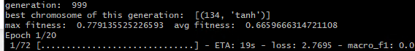
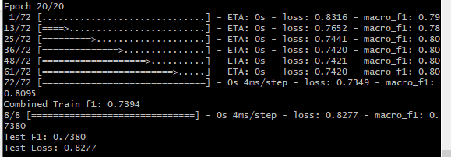
However, there were better results in previous generations: 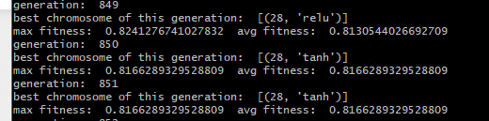
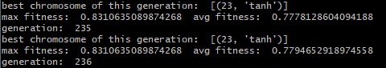
Although, (“tanh”, 134) is the best chromosome of the last generation. It doesn’t seem to be good enough. So, no need to test it further on E=500.

Run E
E=200, I=1000, M=0.15, S=8, P=24, lr=0.001
I added a convergence criterion that wasn’t proper so the algorithm would stop when avg_fitness and highest_fitness are within 0.03.
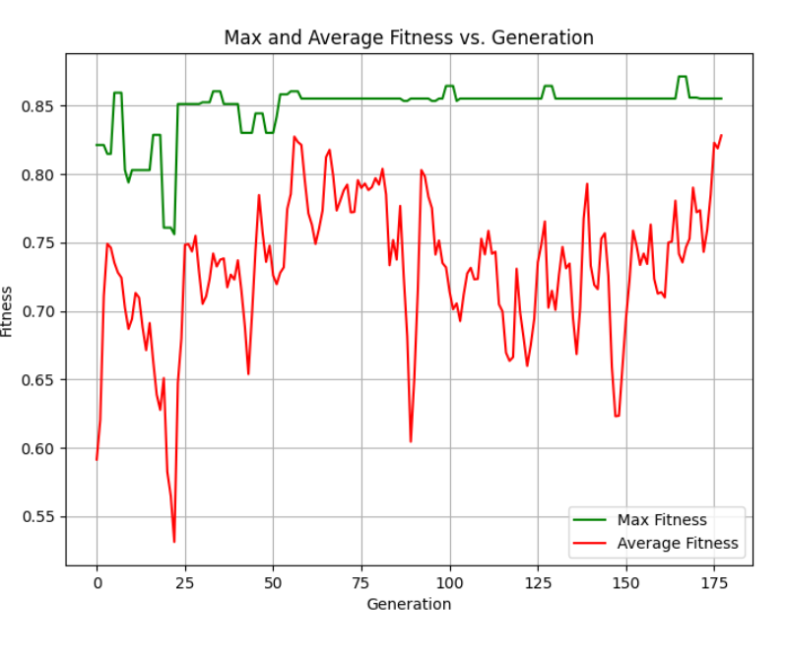
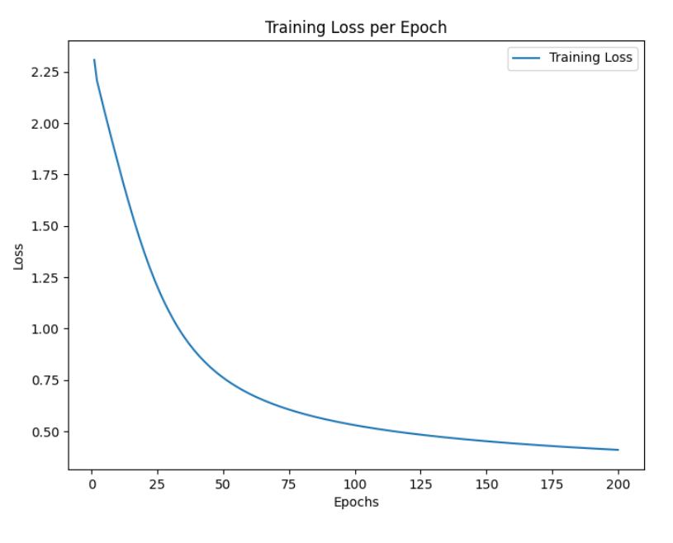
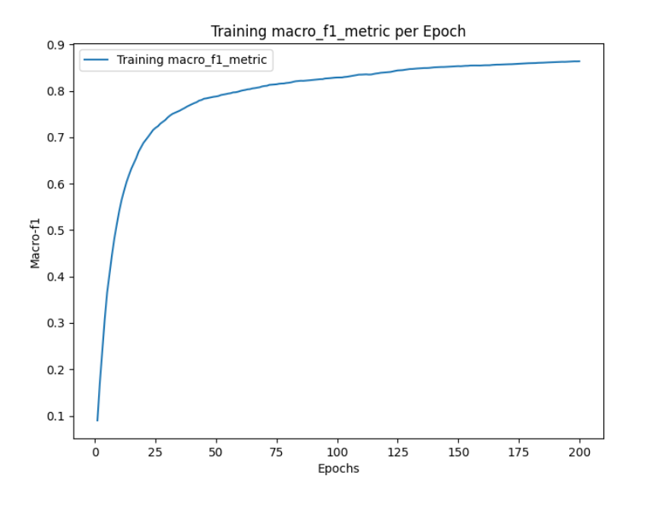
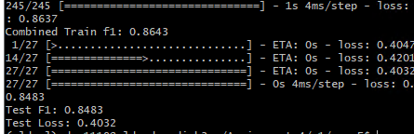
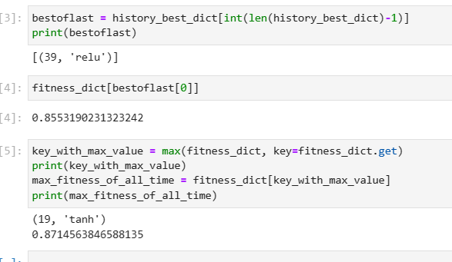

RunF
E=300, I=2000, M=0.05, S=6, P=30, lr=0.001,
Also stopped because of improper convergence criteria.
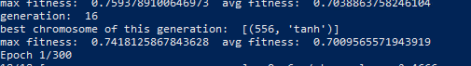
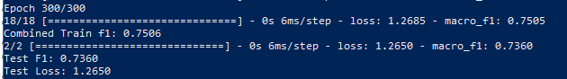
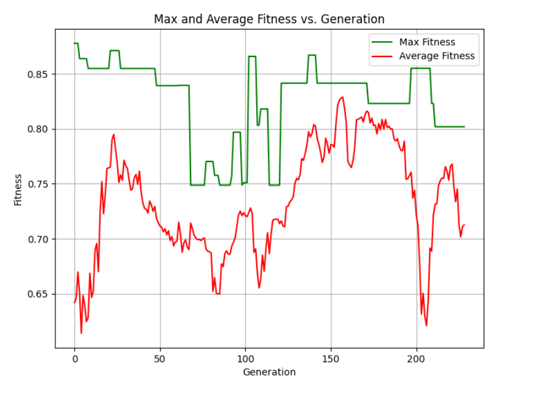
This code stopped too early, so we won’t be testing this chromosome.

RunG-v1:
E=400, I=1000, M=0.05, S=4, P=16, lr=0.01

Version 1
(Early stop due to unrealistic convergence condition)

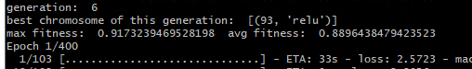
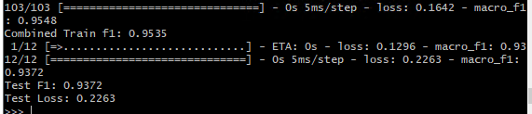

Version 2

(Still running )
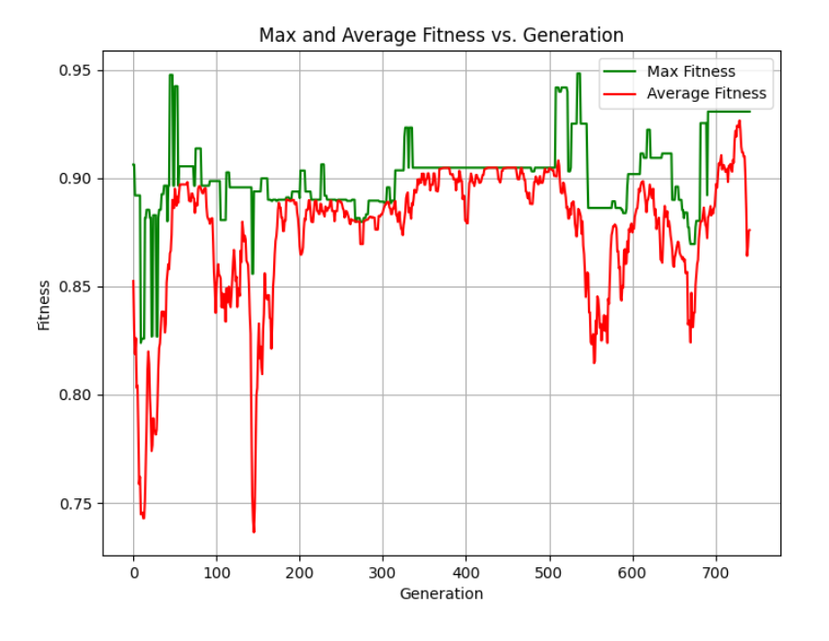
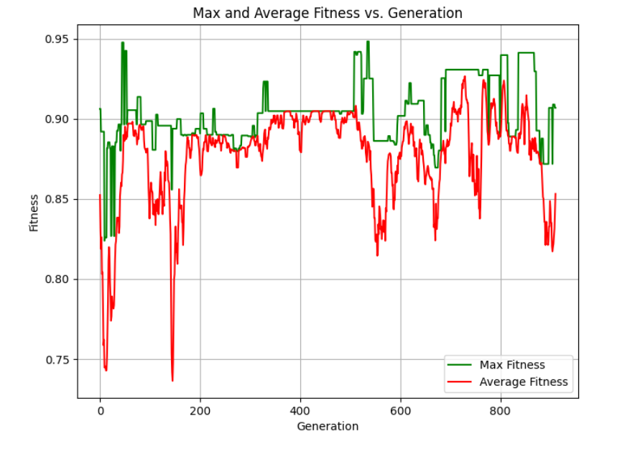
We notice more stability for this run, because the mutation rate is small and S/P ratio is also
small. And there is some convergence behavior, but the algorithm is still exploring.
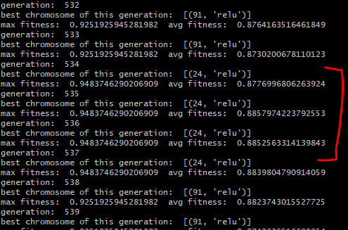
But the best chromosome in previous generations is (24, ‘relu’)
However, the last best chromosome is (29, tanh)
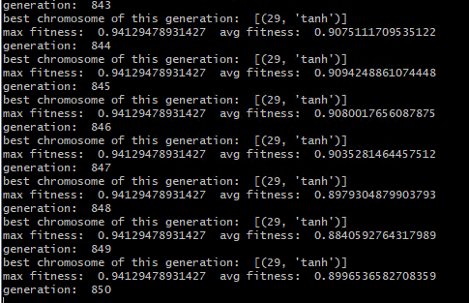
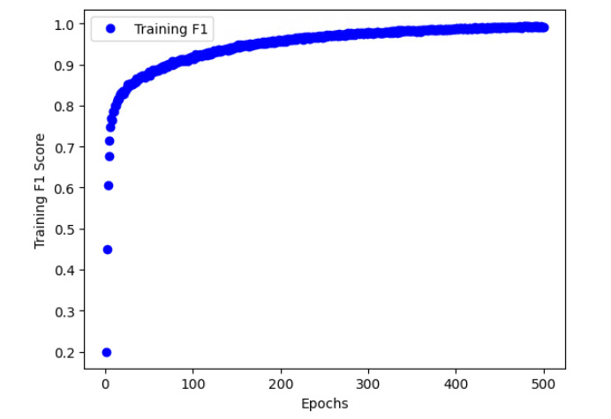
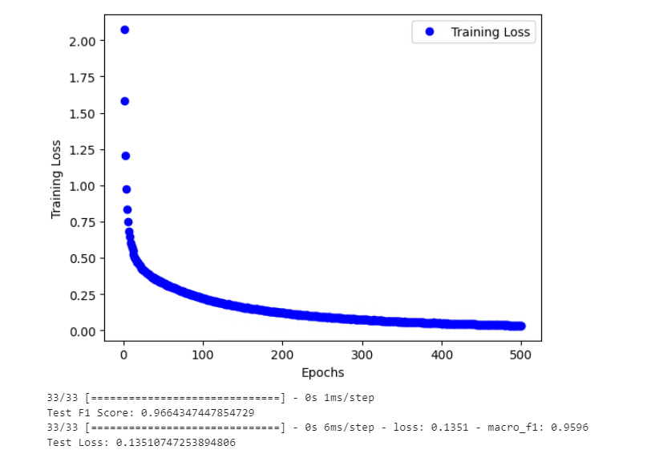

Run H
E=600, I=200, M=0.1, S=4, P=12, lr=0.01
Got interrupted because of server issues or technical issues. 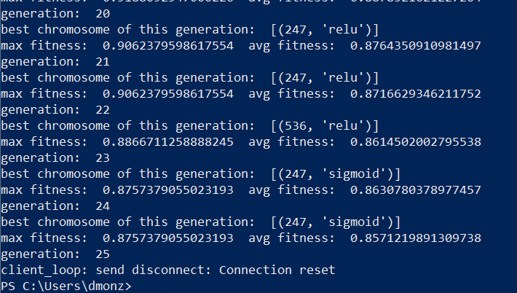
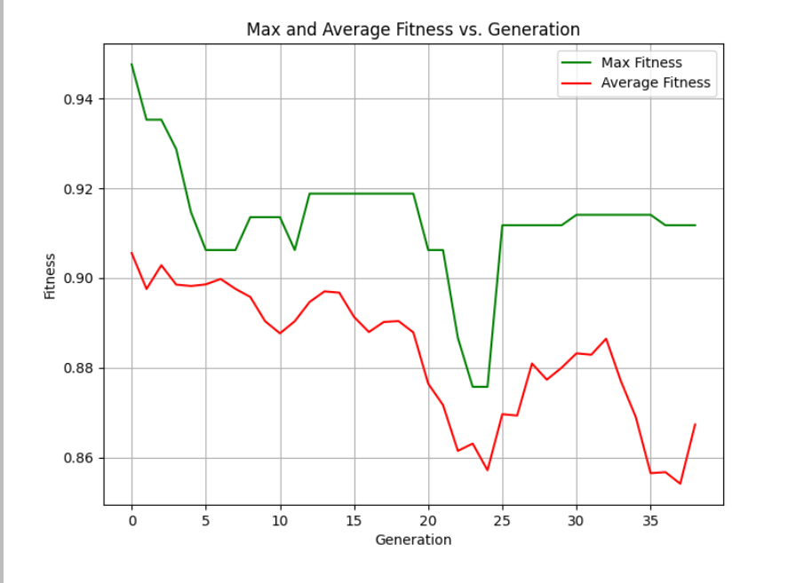
Tried to continue running after interruption, but the server crashed again.
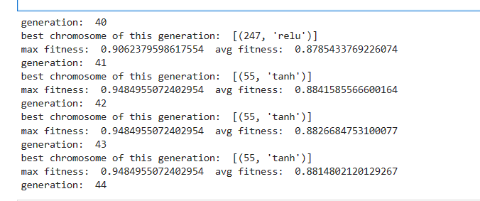
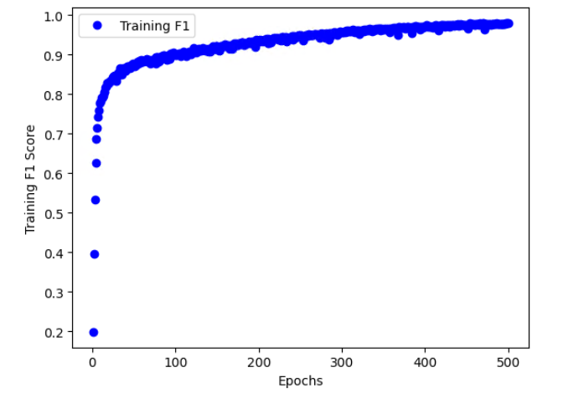
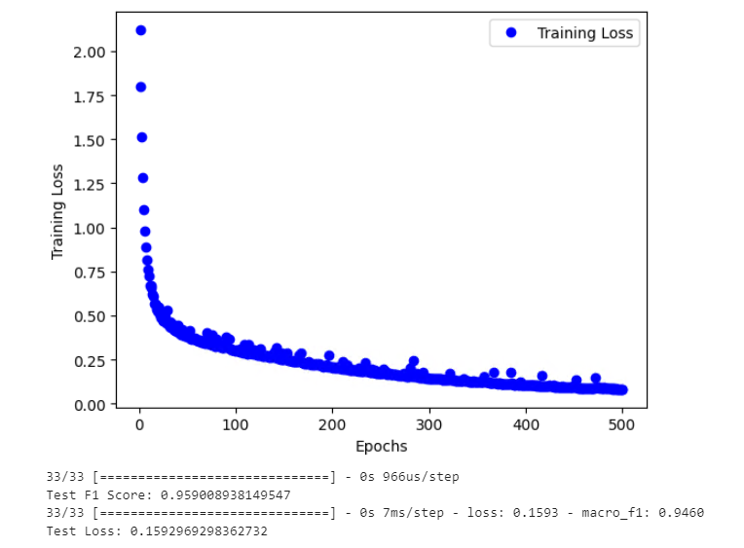

GA evaluation of hyperparameters
GA algorithm should converge to solutions (hyperparameters) that result in high validation F1 score. It is possible to achieve validation F1 score of over 95% for the given data inputs and architecture.
In summary:
runA 23, relu
runB 22, tanh
runC 23, relu
runD 134, tanh
runE 39, relu
runG 29, tanh
run H 55, tanh
The output of GA depends on different variables (E, P, S, lr, M). For this reason different runs gave different outputs, however all runs gave similar outputs, so relatively small batch size between 23 and 134, and only relu or tanh.
We notice that the best combination to allow GA to converge (similar to run G), is to use small M value, and small S/P ratio, and also we must use high E to get more accurate fitness.
However using high E leads to high computational time, and causes the code to get interrupted due to limited resources, for this reason it was avoided in most runs.
If I had more time, I would test more runs with small M and S/P values until the run converges.
Out of all values hyperparameters: relu, and 23 seem best.
Possible improvements:
- Using adaptive removal to remove a different number of old chromosomes in each generation
- Varying mutation probability
- Improve the optimizer ( use an adaptive learning rate, and or momentum value).

Bayesian Optimization

BO implementation & results
Correct use of the package. Report of progress and final values that demonstrate proper searching and tuning of the hyperparameters.

Report the progress output and the final values of the hyperparameters found by the algorithm.

Train the model on the training and validation data using the selected hyperparameters. Plot the training F1 score versus the training epochs.

Evaluate the model on the test data. Report the test F1 score.
In this algorithm, I changed the activation index, so if it is 0.5, the index is int(0.5), which is 0. And the activation function would be relu. For the batch size, I alternated the exponent, and then got 2 to the power of the decimal exponent, and took the integer value of that value.
- activation = ['relu', 'sigmoid', 'tanh'][int(activation_ind)]
- batch_size = int(2 ** batch_size_exp)
- pbounds={'activation_ind': (0, 2.999), 'batch_size_exp': (4, 10)},
The default learning rate for the SGD optimizer in Keras is typically set to 0.01. However, ins some codes, I changed the learning rate to 0.001.
Note that initially, I set the number of iterations for the runs, hoping to explore that many iterations, however, I had so many interruptions with this package. ( Also due to the spawning issue of the servers). So I couldn’t run all the iterations for most of the runs.

Run A
E=100, lr=0.01
(Was interrupted due to server crash)
| iteration | target | activation index| batch_size exponent |
-------------------------------------------------
| 1 | 0.8472 | 0.4623 | 8.44 |
| 2 | 0.8751 | 0.7897 | 7.202 |
| 3 | 0.8044 | 0.04371 | 9.512 |
| 4 | 0.9296 | 2.701 | 4.201 |
| 5 | 0.9228 | 2.87 | 4.823 |
| 6 | 0.9298 | 0.0 | 4.0 |
| 7 | 0.8923 | 1.332 | 4.0 |
| 8 | 0.9034 | 0.0 | 5.33 |
| 9 | 0.8691 | 2.999 | 7.645 |
| 10 | 0.776 | 2.999 | 10.0 |
| 11 | 0.9374 | 2.999 | 4.0 |
| 12 | 0.8937 | 2.999 | 6.066 |
| 13 | 0.9255 | 2.999 | 4.283 |
| 14 | 0.8718 | 1.722 | 5.538 |
| 15 | 0.9145 | 0.0 | 4.527 |
| 16 | 0.876 | 0.009181 | 6.567 |
| 17 | 0.9321 | 2.346 | 4.02 |
| 18 | 0.9364 | 2.706 | 4.0 |
| 19 | 0.9346 | 2.835 | 4.0 |
| 20 | 0.8185 | 1.984 | 7.0 |
| 21 | 0.9334 | 0.4783 | 4.0 |
| 22 | 0.9137 | 0.7499 | 4.832 |
| 23 | 0.9023 | 2.983 | 5.335 |
| 24 | 0.9152 | 2.215 | 4.735 |
| 25 | 0.9272 | 0.4515 | 4.316 |
| 26 | 0.8445 | 0.657 | 5.686 |
| 27 | 0.8263 | 0.0 | 7.534 |
| 28 | 0.6202 | 1.724 | 8.572 |
| 29 | 0.8722 | 2.999 | 6.869 |
| 30 | 0.885 | 1.412 | 4.709 |
| 31 | 0.901 | 2.44 | 5.337 |
| 32 | 0.9323 | 0.2651 | 4.0 |
| 33 | 0.9168 | 0.8065 | 4.299 |
| 34 | 0.9159 | 0.3287 | 4.824 |
| 35 | 0.9113 | 2.568 | 4.597 |
| 36 | 0.9314 | 2.126 | 4.286 |

The best hyperparameter run of this set is:
| 11 | 0.9374 | 2.999 | 4.0 |
Which refers to {“tanh”, batch size = 16}
Trained model with E= 500, lr=0.01:
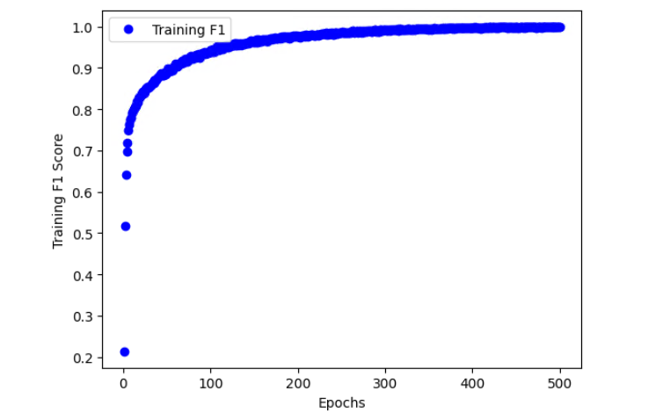
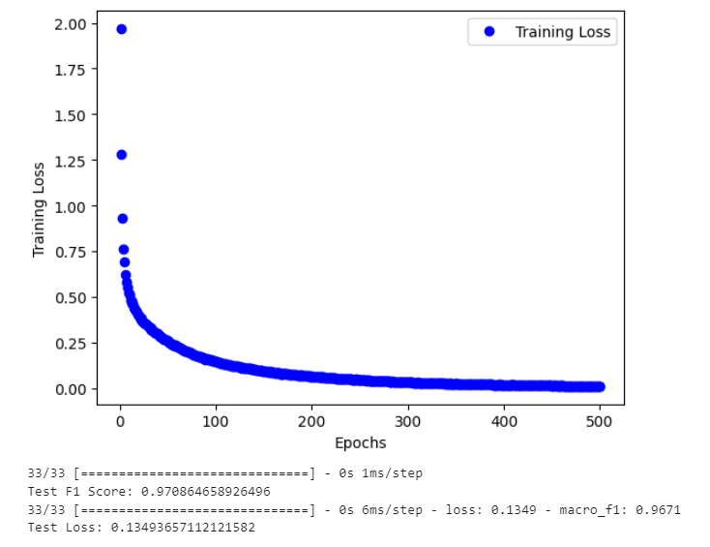

Run B
E=300, lr=0.01
(I ran this locally so it was super slow, I ran it for almost 20 hours and this is how many iterations I got)
| iter | target | activa... | batch_... |
-------------------------------------------------
| 1 | 0.8883 | 0.4623 | 8.44 |
| 2 | 0.896 | 0.7897 | 7.202 |
| 3 | 0.87 | 0.04371 | 9.512 |
| 4 | 0.9592 | 2.701 | 4.201 |
| 5 | 0.9522 | 2.87 | 4.823 |
| 6 | 0.9524 | 0.0 | 4.0 |
| 7 | 0.9265 | 1.434 | 4.0 |
| 8 | 0.8566 | 2.999 | 10.0 |
| 9 | 0.9425 | 0.0 | 5.241 |
| 10 | 0.9609 | 2.999 | 4.0 |
| 11 | 0.9099 | 2.999 | 6.63 |
| 12 | 0.9571 | 2.999 | 4.342 |
| 13 | 0.9026 | 1.869 | 5.292 |
| 14 | 0.9539 | 0.0 | 4.545 |
| 15 | 0.9589 | 2.548 | 4.0 |
| 16 | 0.9582 | 2.803 | 4.0 |
| 17 | 0.8811 | 2.999 | 8.031 |
| 18 | 0.9086 | 0.0 | 6.362 |
| 19 | 0.9585 | 2.276 | 4.379 |
| 20 | 0.9579 | 2.546 | 4.507 |
| 21 | 0.9565 | 2.204 | 4.0 |
| 22 | 0.9557 | 2.421 | 4.222 |
| 23 | 0.9467 | 0.6151 | 4.721 |
| 24 | 0.934 | 2.999 | 5.583 |
| 25 | 0.9587 | 0.499 | 4.0 |
| 26 | 0.6716 | 1.399 | 10.0 |
| 27 | 0.8911 | 0.0 | 7.669 |
| 28 | 0.8709 | 1.964 | 7.114 |
| 29 | 0.9197 | 0.7065 | 5.743 |
| 30 | 0.9475 | 0.3362 | 4.302 |

The best hyperparameters for this set are:
| 10 | 0.9609 | 2.999 | 4.0 |
Which refer to activation =”tanh”, batchsize = 16.
This was tested in run A. Same results on the training model.

Run C
E=50, lr=0.001
(Accidentally got interrupted, it took about 20 hours to run these iterations, lost of print out of optimization loop failure which is common due to resource limitation sometimes, so I couldn’t track all iterations)

| 288 | 0.8939 | 2.879 | 4.477 |
| 289 | 0.8969 | 0.3538 | 4.002 |
| 290 | 0.9073 | 2.326 | 4.033 |
| 291 | 0.8864 | 0.2614 | 4.345 |
| 292 | 0.9033 | 0.2993 | 4.038 |
| 293 | 0.9072 | 2.621 | 4.004 |
| 294 | 0.9085 | 0.2759 | 4.024 |
| 295 | 0.9132 | 2.341 | 4.049 |
| 296 | 0.9045 | 2.872 | 4.01 |
| 297 | 0.9037 | 2.71 | 4.074 |
| 298 | 0.8222 | 2.917 | 8.269 |
| 299 | 0.907 | 2.403 | 4.029 |
| 300 | 0.9067 | 2.599 | 4.071 |
| 301 | 0.9134 | 2.731 | 4.056 |
| 302 | 0.9064 | 2.363 | 4.053 |
| 303 | 0.7396 | 0.3537 | 9.377 |
| 304 | 0.9122 | 2.818 | 4.081 |
| 305 | 0.9132 | 2.767 | 4.029 |
| 306 | 0.8381 | 0.2558 | 7.351 |
| 307 | 0.9006 | 2.739 | 4.205 |
| 308 | 0.888 | 0.1869 | 4.346 |
| 309 | 0.8834 | 0.1952 | 4.326 |
| 310 | 0.8807 | 0.213 | 4.347 |
| 311 | 0.9052 | 2.35 | 4.076 |
| 312 | 0.908 | 2.375 | 4.027 |
| 313 | 0.8921 | 0.329 | 4.042 |
| 314 | 0.7649 | 1.887 | 6.597 |
| 315 | 0.4839 | 1.227 | 9.041 |
| 316 | 0.9027 | 0.2592 | 4.003 |
| 317 | 0.8862 | 0.08283 | 4.515 |
| 318 | 0.9044 | 2.861 | 4.083 |
| 319 | 0.555 | 1.327 | 8.074 |
| 320 | 0.8902 | 2.609 | 4.095 |
| 321 | 0.9088 | 2.778 | 4.007 |
| 322 | 0.9071 | 2.781 | 4.059 |
| 323 | 0.8917 | 2.371 | 4.102 |
| 324 | 0.897 | 2.844 | 4.102 |
| 325 | 0.2971 | 1.733 | 9.191 |
| 326 | 0.8702 | 1.43 | 4.374 |
| 327 | 0.9149 | 2.752 | 4.079 |
| 328 | 0.888 | 2.752 | 4.113 |
| 329 | 0.6694 | 1.269 | 7.527 |
| 330 | 0.9117 | 2.867 | 4.054 |
| 331 | 0.9074 | 2.391 | 4.004 |
| 332 | 0.9042 | 2.573 | 4.087 |
| 333 | 0.8992 | 2.711 | 4.1 |
| 334 | 0.2108 | 1.408 | 9.898 |
| 335 | 0.8975 | 2.778 | 4.134 |
| 336 | 0.9005 | 2.909 | 4.46 |
| 337 | 0.9043 | 0.2559 | 4.051 |
| 338 | 0.8824 | 2.779 | 4.09 |
| 339 | 0.9063 | 0.776 | 4.047 |
| 340 | 0.9102 | 2.833 | 4.008 |
| 341 | 0.8989 | 0.2127 | 4.49 |

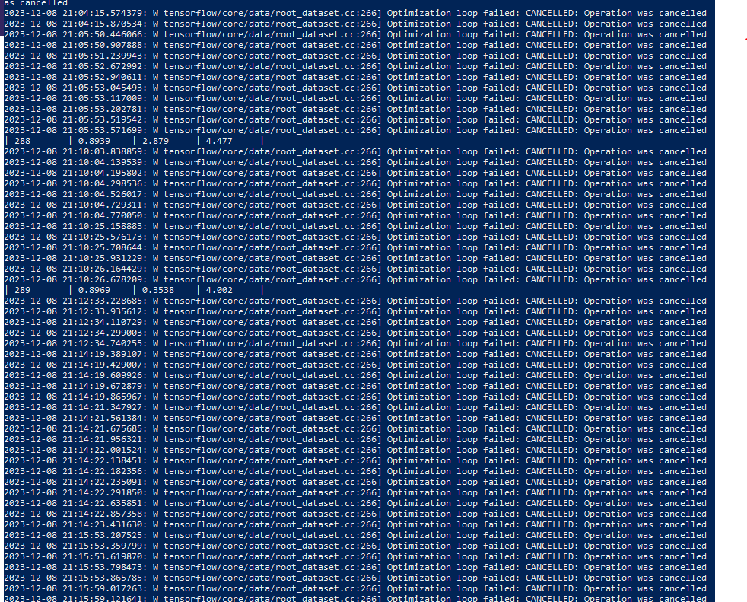
(This error occurs with many users, see: https://discuss.tensorflow.org/t/optimization-loop-failed-cancelled-operation-was-cancelled/1524/45)
None of these hyperparameters is purple, which means that a previous iteration had better performance. However, I cannot track it down from the terminal, due to the clutter of printouts by tensorflow. However, out of these outputs. The best hyperparameter set is:
301 | 0.9134 | 2.731 | 4.056 |
Which refers to activation =”tanh”, batch_size = 16.
Same result as in runs A, and B. Got tested in both.

Run D
E=20, lr=0.01
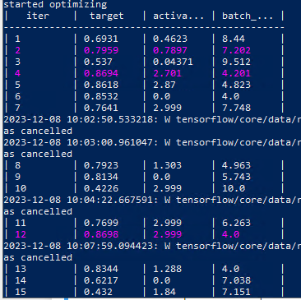
See appendix for the full table (about 690 iterations, took also about 21 hours)
The best iteration was at iteration 67:
| 67 | 0.8775 | 2.816 | 4.067 |
Which corresponds to hyperparameters = activation = “tanh”, batch_size =16.
Same result as runs A, B, C.

Run E
E=200, lr=0.001

Version 1 (got interrupted)
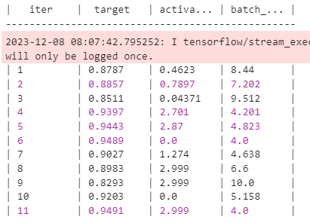

Version 2 (also got interrupted)
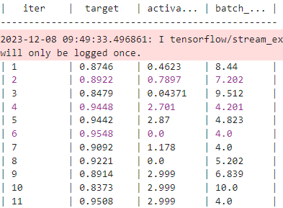

So, the best two sets of hyperparameters:
Set1: activation =”tanh”, batch_size = 16
Set2: activation = “relu”, batch_size =16
Results on training the model, with relu and batch size =16, and E=500, lr=0.01:

Run F
E=300, lr=0.001
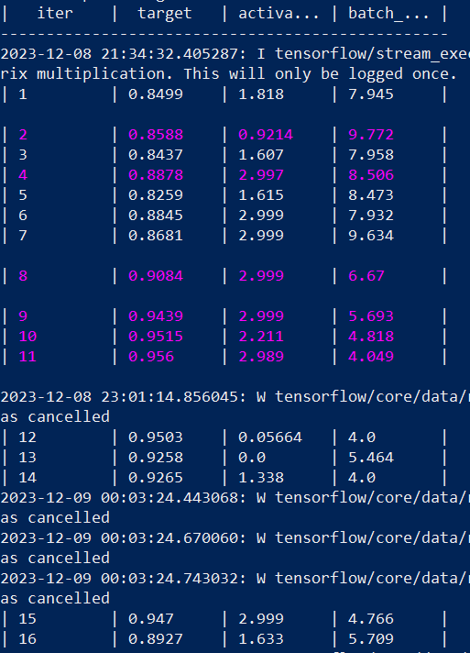
Also got interrupted.
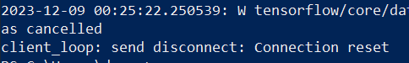
Best set of hyperparameters:
Activation function = “tanh”, batch_size = 16
Same result as in runs previously.

Run G
E=400, lr=0.01
The terminal got cluttered. These are the highest iterations I could track.
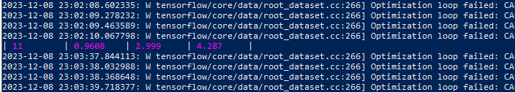
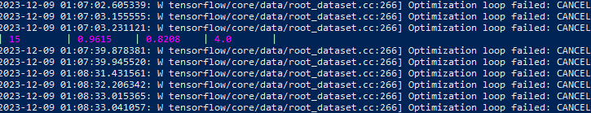
Best set of hyperparameters:
Activation function = “relu”, batch_size = 16
Same as run E.

Run H
E=600, lr=0.01

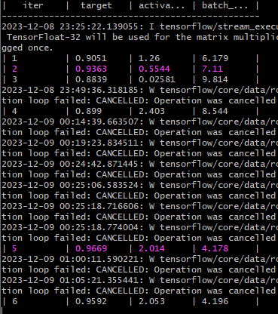
Best set of hyperparameters:
Activation function = “tanh”, batch_size = 18

BO evaluation of hyperparameters
BO algorithm should converge to solutions (hyperparameters) that result in high validation F1 score. It is possible to achieve validation F1 score of over 95% for the given data inputs and architecture.

The highest fitness value I obtained out of all runs was:
0.9669 using activation function = “tanh”, and batch_size =18. However, almost all runs resulted in almost the same set: either “relu” or “tanh” as an activation function, and either batch size=16 or 18. So even with different E values and learning rate values, and with extensive generations exploration (as in run C), these sets are the best.
For this reason, I will test these two sets on the data with E=500 and lr = 0.01.
We notice that although E and lr fluctuated, all runs had similar results. This shows the robustness of BO.
(Note that due to interruptions, I wasn’t able to obtain optimizer.res from BO, so I can perhaps plot the fitness versus iterations, although it is not required.)

Activation function = “tanh”, batch_size = 18
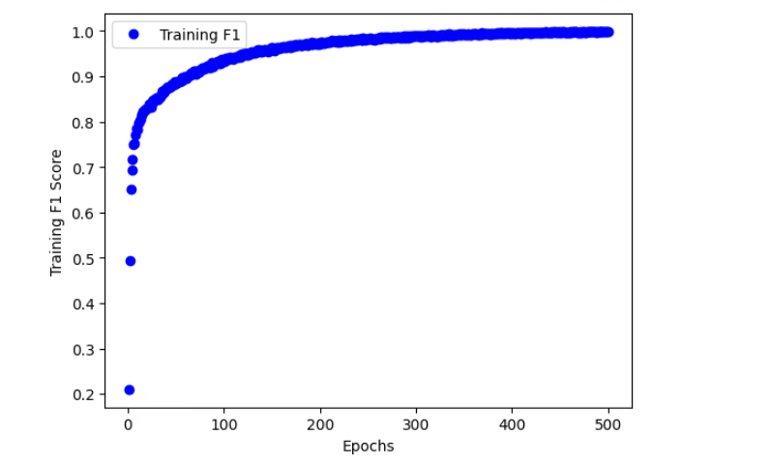
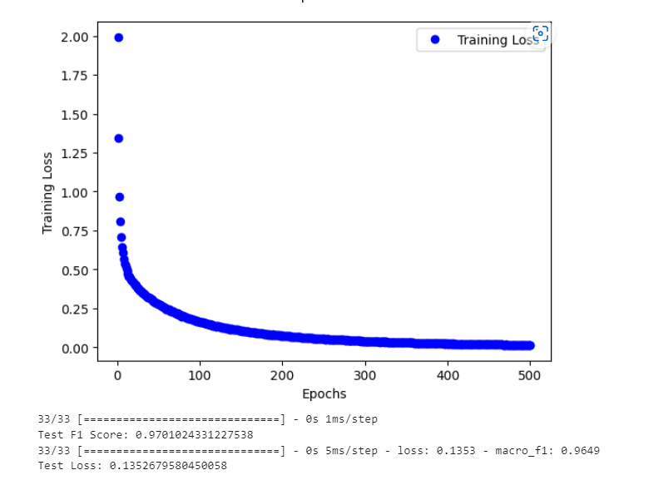

Activation function = “Relu”, batch_size =16
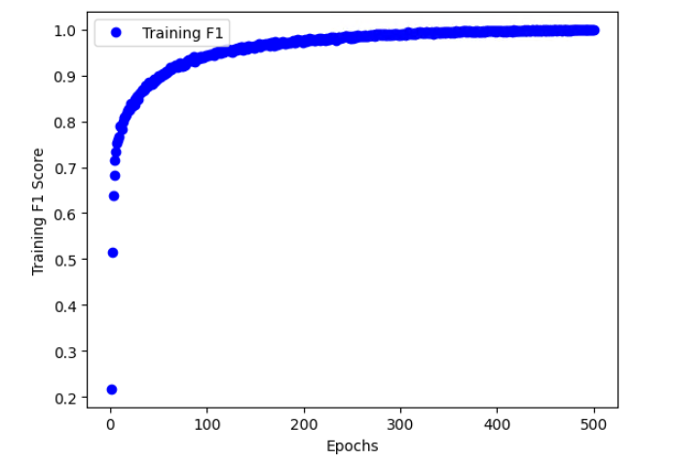
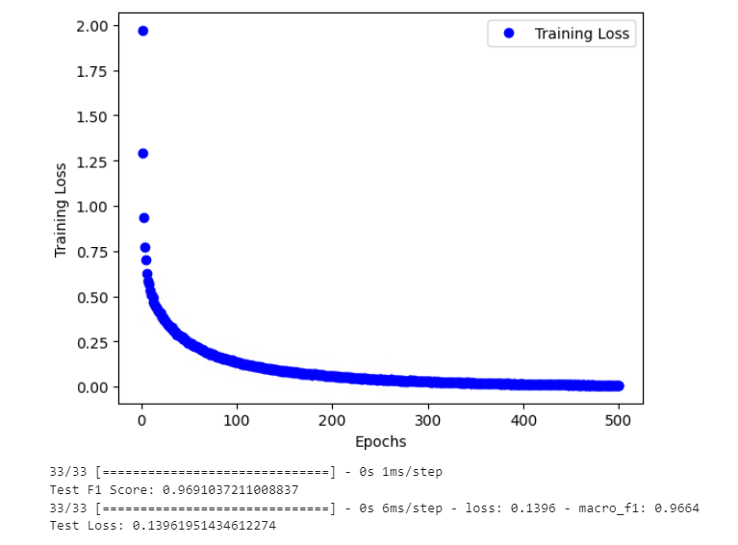

Discuss BO and GA

Compare the hyperparameters chosen by the Genetic Algorithm and the Bayesian Optimization method.
I ran 8 different runs at least for each algorithm. In order to be able to compare the results, I tried to match the hyperparameters in runs. The results between BO and GA didn’t match exactly for any run, however this could be due to technical issues that didn’t let GA to converge properly and the several interruptions of BO. However, both algorithms had close enough values. All runs in BO gave the best batch size as either 16 or 18. While several runs in GA gave the best batch size as 22, 23, 29. So there is some matching.
The best chromosome out of GA runs is (23, relu), and the best chromosome out of BO runs is (tanh, 18), they both give 0.97, however the former is only slightly higher in terms of macro-f1 test result. So both algorithms give reliable and good hyperparameters. However, based on the limited runs I conducted, GA gives slightly better results.

Briefly discuss the pros and cons of the two methods.

Genetic Algorithm Method for Hyper tuning hyperparameters:
Pros:
- It is good at exploring a wide search space by maintaining a population of solutions and evolving them over generations. This helps in finding global optima.
- It can possibly handle parallel evaluations of different solutions, allowing multiple hyperparameter configurations to be tested simultaneously. However, I didn’t utilize this feature in this hw.
- It is versatile and adaptable to various problem types, making it suitable for non-differentiable or complex search spaces.
- It is suitable for discrete hyperparameters or continuous hyperparameters.
- It is a well-trusted method that outperforms several other methods and it is adopted in different fields.
Cons:
- It can take longer to converge to optimal solutions compared to more focused methods. It might need more iterations to converge. And it highly depends on its hyperparameters.
- It might require more computational resources as it explores a larger search space with multiple evaluations.
- Different hyperparameter sets can lead to very different solutions.
- In terms of implementation, it needs a lot of hyperparameter tuning itself in order to get good results.
- Convergence becomes difficult with a big population or mutation rate.
- Since the final result of the best chromosome depend on the final population; one might find the final chromosome to be not as good as other chromosomes in previous generations, as we have seen in some of my runs. However, this issue could be solved with proper convergence and higher computational time. A better improvement of GA is tabu-search.
Bayesian Optimization Method for Hyper tuning hyperparameters:
Pros:
- It focuses on the most promising regions of the search space based on past evaluations, which can lead to faster convergence.
- It constructs a probabilistic model of the objective function, allowing for a more informed search and exploitation of the space.
- It often requires fewer evaluations to find a good solution, making it more sample efficient.
- It is more robust to variations in number of epochs and learning rate of the model. It can still find the best solution.
Cons:
- It might struggle when dealing with categorical or discrete hyperparameters, although adaptations exist.
- It can be sensitive to noisy evaluations and might struggle to distinguish between actual improvements and random fluctuations.
- It can be very computationally intensive.
- The implementation is a black box so it is more difficult to customize.
Comparison:
For complex search spaces or non-differentiable problems, GAs might be more suitable due to their global search capabilities. On the other hand, BO might be preferred when computational resources are limited, as it's often more sample efficient. If the hyperparameters include categorical or discrete values, GAs might be more appropriate, whereas BO suits continuous spaces better.

Notes:
** Please make sure you use the correct packages when running my codes. For example, I tried to use google colab and Kaggle, but due to versions mismatch and even the python versions are different, I got errors in data splitting and SoftMax respectively. Although when I run the code in my local environment or the server (deepdish) the codes run fine with no errors.
So, I don’t recommend you use google colab or Kaggle to run my code.
Acknowledgements:
- Chatgpt
- TA
- Lectures
Appendix

P2- BO - Run D
Progress output table.
| iter | target | activa... | batch_... |
-------------------------------------------------
| 1 | 0.6931 | 0.4623 | 8.44 |
| 2 | 0.7959 | 0.7897 | 7.202 |
| 3 | 0.537 | 0.04371 | 9.512 |
| 4 | 0.8694 | 2.701 | 4.201 |
| 5 | 0.8618 | 2.87 | 4.823 |
| 6 | 0.8532 | 0.0 | 4.0 |
| 7 | 0.7641 | 2.999 | 7.748 |
| 8 | 0.7923 | 1.303 | 4.963 |
| 9 | 0.8134 | 0.0 | 5.743 |
| 10 | 0.4226 | 2.999 | 10.0 |
| 11 | 0.7699 | 2.999 | 6.263 |
| 12 | 0.8698 | 2.999 | 4.0 |
| 13 | 0.8344 | 1.288 | 4.0 |
| 14 | 0.6217 | 0.0 | 7.038 |
| 15 | 0.432 | 1.84 | 7.151 |
| 16 | 0.8576 | 0.2714 | 4.784 |
| 17 | 0.8028 | 2.254 | 5.35 |
| 18 | 0.7423 | 0.8689 | 5.875 |
| 19 | 0.844 | 0.6207 | 4.0 |
| 20 | 0.8758 | 2.002 | 4.004 |
| 21 | 0.7935 | 2.993 | 5.491 |
| 22 | 0.7096 | 2.074 | 4.602 |
| 23 | 0.1904 | 1.714 | 8.86 |
| 24 | 0.8236 | 0.003061 | 5.213 |
| 25 | 0.7997 | 0.6624 | 5.158 |
| 26 | 0.7995 | 2.999 | 7.052 |
| 27 | 0.8449 | 0.0 | 4.465 |
| 28 | 0.8526 | 0.7919 | 4.505 |
| 29 | 0.8433 | 2.995 | 4.364 |
| 30 | 0.8622 | 2.441 | 4.005 |
| 31 | 0.734 | 0.0 | 7.998 |
| 32 | 0.6928 | 1.804 | 5.843 |
| 33 | 0.739 | 0.6296 | 7.718 |
| 34 | 0.8288 | 0.3654 | 4.331 |
| 35 | 0.809 | 0.6447 | 6.567 |
| 36 | 0.8385 | 1.709 | 4.0 |
| 37 | 0.8451 | 2.673 | 5.116 |
| 38 | 0.8629 | 2.8 | 4.012 |
| 39 | 0.7017 | 2.682 | 4.604 |
| 40 | 0.8589 | 0.7084 | 4.537 |
| 41 | 0.8528 | 2.982 | 5.064 |
| 42 | 0.6655 | 2.999 | 8.538 |
| 43 | 0.867 | 0.7066 | 4.545 |
| 44 | 0.8459 | 0.264 | 4.782 |
| 45 | 0.8536 | 0.5348 | 4.801 |
| 46 | 0.8468 | 0.9203 | 4.767 |
| 47 | 0.1209 | 1.782 | 9.919 |
| 48 | 0.8174 | 1.3 | 4.445 |
| 49 | 0.5945 | 1.392 | 6.777 |
| 50 | 0.7846 | 0.3358 | 5.459 |
| 51 | 0.8229 | 0.2422 | 6.216 |
| 52 | 0.8412 | 2.549 | 5.81 |
| 53 | 0.7621 | 0.7917 | 7.205 |
| 54 | 0.7539 | 0.74 | 7.163 |
| 55 | 0.793 | 0.7918 | 7.153 |
| 56 | 0.8652 | 0.7795 | 4.552 |
| 57 | 0.6917 | 0.7378 | 4.608 |
| 58 | 0.4699 | 2.945 | 9.085 |
| 59 | 0.8372 | 1.986 | 4.054 |
| 60 | 0.8703 | 2.046 | 4.033 |
| 61 | 0.763 | 0.1331 | 7.636 |
| 62 | 0.8534 | 2.749 | 4.233 |
| 63 | 0.8505 | 0.2616 | 4.778 |
| 64 | 0.8431 | 0.328 | 4.74 |
| 65 | 0.8342 | 0.2677 | 4.709 |
| 66 | 0.8472 | 2.772 | 4.158 |
| 67 | 0.8775 | 2.816 | 4.067 |
| 68 | 0.8577 | 2.027 | 4.908 |
| 69 | 0.44 | 1.457 | 7.705 |
| 70 | 0.8612 | 2.874 | 4.041 |
| 71 | 0.859 | 2.953 | 4.053 |
| 72 | 0.8622 | 2.737 | 4.064 |
| 73 | 0.8477 | 2.873 | 4.122 |
| 74 | 0.8497 | 2.671 | 4.28 |
| 75 | 0.8471 | 0.3582 | 4.805 |
| 76 | 0.5797 | 0.8526 | 9.033 |
| 77 | 0.7374 | 2.432 | 8.094 |
| 78 | 0.8463 | 2.704 | 4.336 |
| 79 | 0.8379 | 2.698 | 4.123 |
| 80 | 0.8422 | 0.4493 | 4.784 |
| 81 | 0.8503 | 0.4839 | 4.851 |
| 82 | 0.8574 | 2.617 | 4.194 |
| 83 | 0.854 | 2.976 | 4.523 |
| 84 | 0.8135 | 2.972 | 4.449 |
| 85 | 0.8168 | 2.91 | 4.894 |
| 86 | 0.8422 | 2.944 | 4.796 |
| 87 | 0.8583 | 2.88 | 4.745 |
| 88 | 0.3259 | 1.566 | 7.832 |
| 89 | 0.8631 | 2.524 | 4.057 |
| 90 | 0.845 | 2.438 | 4.092 |
| 91 | 0.8427 | 2.528 | 4.149 |
| 92 | 0.851 | 2.605 | 4.087 |
| 93 | 0.7108 | 2.949 | 4.641 |
| 94 | 0.8646 | 2.641 | 4.009 |
| 95 | 0.8522 | 2.787 | 4.788 |
| 96 | 0.8603 | 0.8726 | 4.552 |
| 97 | 0.7332 | 1.097 | 5.609 |
| 98 | 0.8246 | 0.9064 | 4.66 |
| 99 | 0.8699 | 2.344 | 4.028 |
| 100 | 0.8427 | 2.332 | 4.107 |
| 101 | 0.4769 | 0.6656 | 9.055 |
| 102 | 0.8266 | 1.382 | 4.263 |
| 103 | 0.8611 | 0.6183 | 4.571 |
| 104 | 0.868 | 2.26 | 4.009 |
| 105 | 0.4857 | 2.464 | 7.507 |
| 106 | 0.8657 | 2.175 | 4.049 |
| 107 | 0.806 | 2.667 | 7.141 |
| 108 | 0.6404 | 0.3408 | 8.742 |
| 109 | 0.8297 | 2.211 | 4.128 |
| 110 | 0.8504 | 0.6215 | 4.002 |
| 111 | 0.8277 | 0.6595 | 4.094 |
| 112 | 0.8519 | 0.7009 | 4.021 |
| 113 | 0.8516 | 0.5555 | 4.071 |
| 114 | 0.805 | 0.5388 | 4.665 |
| 115 | 0.8362 | 2.095 | 4.113 |
| 116 | 0.8658 | 2.701 | 4.199 |
| 117 | 0.8421 | 2.009 | 5.008 |
| 118 | 0.7978 | 1.748 | 4.762 |
| 119 | 0.8431 | 2.117 | 4.962 |
| 120 | 0.7939 | 1.929 | 4.923 |
| 121 | 0.8628 | 2.12 | 4.848 |
| 122 | 0.322 | 1.11 | 7.881 |
| 123 | 0.7189 | 2.308 | 8.378 |
| 124 | 0.8604 | 0.9274 | 4.823 |
| 125 | 0.8539 | 2.033 | 4.804 |
| 126 | 0.8445 | 0.9295 | 5.004 |
| 127 | 0.5905 | 1.819 | 6.569 |
| 128 | 0.8504 | 0.8521 | 4.913 |
| 129 | 0.8231 | 2.602 | 5.388 |
| 130 | 0.7967 | 1.035 | 4.8 |
| 131 | 0.2116 | 1.393 | 8.8 |
| 132 | 0.8479 | 0.9865 | 4.917 |
| 133 | 0.8383 | 2.866 | 5.112 |
| 134 | 0.8252 | 2.967 | 5.175 |
| 135 | 0.8449 | 2.769 | 4.994 |
| 136 | 0.8065 | 2.711 | 4.898 |
| 137 | 0.8311 | 2.895 | 4.276 |
| 138 | 0.8486 | 2.886 | 5.012 |
| 139 | 0.4474 | 1.196 | 7.652 |
| 140 | 0.8382 | 0.7972 | 5.029 |
| 141 | 0.5044 | 2.237 | 9.362 |
| 142 | 0.8499 | 2.995 | 4.166 |
| 143 | 0.806 | 2.587 | 5.323 |
| 144 | 0.8361 | 2.748 | 5.211 |
| 145 | 0.812 | 2.825 | 4.394 |
| 146 | 0.6416 | 1.419 | 6.139 |
| 147 | 0.7566 | 0.8803 | 7.454 |
| 148 | 0.8531 | 0.6903 | 4.912 |
| 149 | 0.8577 | 0.5801 | 4.935 |
| 150 | 0.8411 | 0.6748 | 5.016 |
| 151 | 0.8538 | 0.8155 | 4.815 |
| 152 | 0.8489 | 0.6602 | 4.815 |
| 153 | 0.8209 | 0.04773 | 4.103 |
| 154 | 0.8536 | 0.5166 | 5.054 |
| 155 | 0.8611 | 0.6183 | 4.57 |
| 156 | 0.8207 | 0.4175 | 4.976 |
| 157 | 0.8246 | 1.359 | 4.112 |
| 158 | 0.8324 | 1.855 | 4.026 |
| 159 | 0.8277 | 1.753 | 4.128 |
| 160 | 0.8607 | 0.1201 | 4.002 |
| 161 | 0.08571 | 1.828 | 9.986 |
| 162 | 0.8327 | 1.579 | 4.098 |
| 163 | 0.8592 | 0.2446 | 4.074 |
| 164 | 0.4928 | 0.3095 | 9.615 |
| 165 | 0.8139 | 0.3744 | 4.156 |
| 166 | 0.8403 | 0.2262 | 4.213 |
| 167 | 0.8505 | 0.1181 | 4.358 |
| 168 | 0.8192 | 2.566 | 6.365 |
| 169 | 0.8482 | 0.1531 | 4.49 |
| 170 | 0.8269 | 0.2424 | 4.377 |
| 171 | 0.5072 | 2.773 | 9.929 |
| 172 | 0.7036 | 0.07444 | 4.599 |
| 173 | 0.8542 | 0.2333 | 4.511 |
| 174 | 0.8272 | 1.221 | 4.196 |
| 175 | 0.8304 | 1.463 | 4.0 |
| 176 | 0.8363 | 0.0 | 4.305 |
| 177 | 0.854 | 0.3904 | 4.492 |
| 178 | 0.8248 | 2.494 | 5.961 |
| 179 | 0.8291 | 2.386 | 5.823 |
| 180 | 0.7426 | 0.6892 | 5.878 |
| 181 | 0.8358 | 0.5224 | 4.392 |
| 182 | 0.7593 | 2.438 | 5.687 |
| 183 | 0.8257 | 2.676 | 5.914 |
| 184 | 0.8479 | 0.3557 | 4.0 |
| 185 | 0.8146 | 2.692 | 5.753 |
| 186 | 0.8094 | 0.4049 | 5.159 |
| 187 | 0.8089 | 2.263 | 4.863 |
| 188 | 0.8332 | 1.148 | 4.063 |
| 189 | 0.819 | 1.031 | 4.534 |
| 190 | 0.8227 | 1.561 | 4.262 |
| 191 | 0.7782 | 1.096 | 5.04 |
| 192 | 0.8187 | 1.462 | 4.421 |
| 193 | 0.8351 | 0.5419 | 4.247 |
| 194 | 0.8289 | 2.78 | 5.375 |
| 195 | 0.5074 | 2.141 | 8.886 |
| 196 | 0.8393 | 2.712 | 5.525 |
| 197 | 0.8175 | 2.832 | 5.626 |
| 198 | 0.8188 | 1.133 | 4.353 |
| 199 | 0.829 | 1.064 | 4.201 |
| 200 | 0.8371 | 0.9536 | 4.384 |
| 201 | 0.8441 | 2.109 | 5.129 |
| 202 | 0.7778 | 1.969 | 5.165 |
| 203 | 0.8401 | 2.272 | 5.094 |
| 204 | 0.8178 | 2.599 | 6.456 |
| 205 | 0.8586 | 2.517 | 5.077 |
| 206 | 0.8313 | 2.407 | 4.998 |
| 207 | 0.8263 | 2.409 | 5.161 |
| 208 | 0.8386 | 2.579 | 4.978 |
| 209 | 0.6627 | 0.2331 | 8.476 |
| 210 | 0.8196 | 0.9115 | 4.246 |
| 211 | 0.8564 | 0.9852 | 4.077 |
| 212 | 0.8582 | 2.475 | 4.847 |
| 213 | 0.8564 | 0.8735 | 4.001 |
| 214 | 0.8453 | 2.388 | 4.738 |
| 215 | 0.8257 | 0.8567 | 4.125 |
| 216 | 0.1122 | 1.937 | 9.675 |
| 217 | 0.826 | 2.309 | 5.988 |
| 218 | 0.8146 | 2.222 | 5.841 |
| 219 | 0.8194 | 2.393 | 6.142 |
| 220 | 0.8227 | 2.579 | 6.118 |
| 221 | 0.8141 | 2.748 | 6.086 |
| 222 | 0.7953 | 0.8692 | 5.185 |
| 223 | 0.8239 | 2.706 | 6.269 |
| 224 | 0.8316 | 1.731 | 4.309 |
| 225 | 0.815 | 1.639 | 4.44 |
| 226 | 0.7746 | 2.844 | 5.865 |
| 227 | 0.8257 | 1.892 | 4.265 |
| 228 | 0.8525 | 2.41 | 4.283 |
| 229 | 0.7962 | 1.733 | 4.812 |
| 230 | 0.8536 | 2.512 | 4.392 |
| 231 | 0.8037 | 2.372 | 4.426 |
| 232 | 0.8514 | 2.253 | 4.304 |
| 233 | 0.8467 | 2.075 | 4.301 |
| 234 | 0.8172 | 2.168 | 4.411 |
| 235 | 0.8171 | 1.836 | 4.421 |
| 236 | 0.8422 | 0.7862 | 4.805 |
| 237 | 0.8152 | 2.777 | 6.43 |
| 238 | 0.8298 | 2.183 | 6.108 |
| 239 | 0.7794 | 2.27 | 6.254 |
| 240 | 0.8376 | 1.9 | 4.072 |
| 241 | 0.85 | 2.513 | 4.719 |
| 242 | 0.8296 | 2.109 | 5.129 |
| 243 | 0.8705 | 2.734 | 4.071 |
| 244 | 0.8684 | 2.01 | 4.002 |
| 245 | 0.849 | 0.273 | 4.776 |
| 246 | 0.8482 | 2.872 | 4.749 |
| 247 | 0.8404 | 2.114 | 5.12 |
| 248 | 0.8621 | 0.9847 | 4.068 |
| 249 | 0.8752 | 2.352 | 4.034 |
| 250 | 0.5851 | 2.863 | 9.577 |
| 251 | 0.8694 | 2.267 | 4.005 |
| 252 | 0.8683 | 2.45 | 4.004 |
| 253 | 0.8419 | 2.098 | 5.116 |
| 254 | 0.8645 | 2.812 | 4.059 |
| 255 | 0.8706 | 2.005 | 4.01 |
| 256 | 0.858 | 0.8819 | 4.557 |
| 257 | 0.8698 | 2.824 | 4.063 |
| 258 | 0.799 | 0.5006 | 6.842 |
| 259 | 0.8641 | 2.632 | 4.004 |
| 260 | 0.8512 | 0.9732 | 4.069 |
| 261 | 0.8592 | 2.265 | 4.021 |
| 262 | 0.8618 | 2.172 | 4.059 |
| 263 | 0.8643 | 2.058 | 4.035 |
| 264 | 0.8606 | 0.8722 | 4.565 |
| 265 | 0.8763 | 2.354 | 4.024 |
| 266 | 0.8413 | 2.104 | 5.117 |
| 267 | 0.7834 | 2.705 | 7.183 |
| 268 | 0.8682 | 2.531 | 4.048 |
| 269 | 0.8734 | 2.789 | 4.009 |
| 270 | 0.8585 | 2.112 | 4.857 |
| 271 | 0.844 | 0.9961 | 4.073 |
| 272 | 0.8594 | 0.863 | 4.56 |
| 273 | 0.836 | 2.153 | 5.109 |
| 274 | 0.8669 | 2.04 | 4.048 |
| 275 | 0.8665 | 2.792 | 4.019 |
| 276 | 0.8173 | 0.03716 | 6.064 |
| 277 | 0.8649 | 2.363 | 4.04 |
| 278 | 0.8631 | 2.034 | 4.037 |
| 279 | 0.8253 | 2.234 | 6.282 |
| 280 | 0.863 | 2.159 | 4.05 |
| 281 | 0.8642 | 2.828 | 4.076 |
| 282 | 0.8769 | 2.375 | 4.032 |
| 283 | 0.858 | 0.8601 | 4.545 |
| 284 | 0.8516 | 2.217 | 4.372 |
| 285 | 0.8072 | 2.125 | 4.86 |
| 286 | 0.8655 | 2.103 | 4.848 |
| 287 | 0.8666 | 2.169 | 4.038 |
| 288 | 0.8621 | 2.879 | 4.477 |
| 289 | 0.8619 | 2.54 | 4.059 |
| 290 | 0.8647 | 0.7893 | 4.561 |
| 291 | 0.8563 | 0.8007 | 4.811 |
| 292 | 0.862 | 2.386 | 4.027 |
| 293 | 0.8499 | 2.449 | 4.015 |
| 294 | 0.8636 | 2.375 | 4.043 |
| 295 | 0.8777 | 2.816 | 4.083 |
| 296 | 0.8678 | 2.723 | 4.059 |
| 297 | 0.8651 | 2.823 | 4.047 |
| 298 | 0.6734 | 2.917 | 8.269 |
| 299 | 0.8675 | 2.986 | 4.001 |
| 300 | 0.8717 | 2.807 | 4.073 |
| 301 | 0.8697 | 2.054 | 4.048 |
| 302 | 0.8562 | 0.78 | 4.569 |
| 303 | 0.524 | 0.3537 | 9.377 |
| 304 | 0.8781 | 2.374 | 4.015 |
| 305 | 0.8617 | 2.874 | 4.838 |
| 306 | 0.7857 | 0.2558 | 7.351 |
| 307 | 0.7192 | 0.004723 | 8.044 |
| 308 | 0.872 | 2.804 | 4.043 |
| 309 | 0.8655 | 2.383 | 4.006 |
| 310 | 0.8757 | 2.813 | 4.028 |
| 311 | 0.8686 | 2.79 | 4.051 |
| 312 | 0.8731 | 2.778 | 4.017 |
| 313 | 0.8567 | 2.721 | 4.072 |
| 314 | 0.5644 | 1.887 | 6.597 |
| 315 | 0.201 | 1.227 | 9.041 |
| 316 | 0.8503 | 0.8109 | 4.797 |
| 317 | 0.8454 | 0.08283 | 4.515 |
| 318 | 0.8711 | 2.185 | 4.037 |
| 319 | 0.2767 | 1.327 | 8.074 |
| 320 | 0.7897 | 1.866 | 5.073 |
| 321 | 0.8677 | 2.778 | 4.039 |
| 322 | 0.8622 | 2.861 | 4.835 |
| 323 | 0.8672 | 2.623 | 4.017 |
| 324 | 0.8719 | 2.986 | 4.016 |
| 325 | 0.1498 | 1.733 | 9.191 |
| 326 | 0.8279 | 1.43 | 4.374 |
| 327 | 0.8662 | 2.178 | 4.019 |
| 328 | 0.8635 | 2.023 | 4.019 |
| 329 | 0.4 | 1.269 | 7.527 |
| 330 | 0.8633 | 2.639 | 4.027 |
| 331 | 0.868 | 2.792 | 4.036 |
| 332 | 0.5832 | 0.251 | 8.95 |
| 333 | 0.8704 | 2.84 | 4.062 |
| 334 | 0.8715 | 2.019 | 4.047 |
| 335 | 0.8676 | 2.854 | 4.042 |
| 336 | 0.8672 | 2.84 | 4.036 |
| 337 | 0.8644 | 2.048 | 4.066 |
| 338 | 0.8662 | 2.795 | 4.085 |
| 339 | 0.8617 | 2.859 | 4.06 |
| 340 | 0.8337 | 2.0 | 4.041 |
| 341 | 0.8743 | 2.826 | 4.022 |
| 342 | 0.8629 | 2.786 | 4.074 |
| 343 | 0.7088 | 0.3358 | 8.313 |
| 344 | 0.865 | 2.2 | 4.026 |
| 345 | 0.7447 | 0.5153 | 7.721 |
| 346 | 0.6763 | 1.053 | 6.099 |
| 347 | 0.8704 | 2.196 | 4.049 |
| 348 | 0.8668 | 2.85 | 4.077 |
| 349 | 0.7331 | 0.8089 | 7.813 |
| 350 | 0.3309 | 0.2175 | 9.716 |
| 351 | 0.8711 | 2.578 | 4.571 |
| 352 | 0.875 | 2.029 | 4.06 |
| 353 | 0.8725 | 2.006 | 4.067 |
| 354 | 0.8664 | 2.025 | 4.075 |
| 355 | 0.8718 | 2.561 | 4.57 |
| 356 | 0.8664 | 2.762 | 4.051 |
| 357 | 0.8055 | 1.702 | 4.791 |
| 358 | 0.8566 | 2.76 | 4.029 |
| 359 | 0.7352 | 2.837 | 4.628 |
| 360 | 0.8536 | 2.042 | 4.01 |
| 361 | 0.4917 | 0.2312 | 9.899 |
| 362 | 0.7294 | 2.573 | 4.589 |
| 363 | 0.8694 | 2.967 | 4.039 |
| 364 | 0.8662 | 2.862 | 4.025 |
| 365 | 0.0776 | 1.048 | 9.966 |
| 366 | 0.7821 | 0.9045 | 7.232 |
| 367 | 0.8201 | 2.119 | 6.547 |
| 368 | 0.8692 | 2.962 | 4.013 |
| 369 | 0.868 | 2.945 | 4.035 |
| 370 | 0.8709 | 2.845 | 4.017 |
| 371 | 0.8618 | 2.757 | 4.082 |
| 372 | 0.803 | 2.544 | 6.245 |
| 373 | 0.8622 | 2.62 | 4.036 |
| 374 | 0.8577 | 2.747 | 4.043 |
| 375 | 0.5899 | 2.927 | 9.02 |
| 376 | 0.8527 | 2.734 | 4.093 |
| 377 | 0.8459 | 2.829 | 4.095 |
| 378 | 0.8715 | 2.972 | 4.024 |
| 379 | 0.8538 | 0.7887 | 4.532 |
| 380 | 0.8634 | 2.572 | 4.555 |
| 381 | 0.8618 | 2.985 | 4.039 |
| 382 | 0.8568 | 0.7734 | 4.519 |
| 383 | 0.7583 | 0.474 | 7.519 |
| 384 | 0.8562 | 2.718 | 4.21 |
| 385 | 0.8591 | 2.823 | 4.001 |
| 386 | 0.8672 | 2.355 | 4.006 |
| 387 | 0.8479 | 2.781 | 4.096 |
| 388 | 0.8612 | 2.192 | 4.069 |
| 389 | 0.8675 | 2.215 | 4.055 |
| 390 | 0.8654 | 2.635 | 4.053 |
| 391 | 0.6827 | 0.9022 | 7.686 |
| 392 | 0.869 | 2.608 | 4.067 |
| 393 | 0.8634 | 2.622 | 4.079 |
| 394 | 0.636 | 0.7874 | 8.765 |
| 395 | 0.7523 | 2.834 | 7.814 |
| 396 | 0.8666 | 2.212 | 4.079 |
| 397 | 0.821 | 0.3442 | 6.553 |
| 398 | 0.8655 | 2.656 | 4.041 |
| 399 | 0.814 | 2.605 | 6.458 |
| 400 | 0.8686 | 2.938 | 4.014 |
| 401 | 0.8691 | 2.229 | 4.066 |
| 402 | 0.8637 | 2.601 | 4.048 |
| 403 | 0.8768 | 2.727 | 4.037 |
| 404 | 0.5951 | 2.133 | 9.108 |
| 405 | 0.3083 | 1.719 | 8.055 |
| 406 | 0.6826 | 2.012 | 8.533 |
| 407 | 0.8354 | 0.02739 | 4.366 |
| 408 | 0.4574 | 0.2615 | 9.928 |
| 409 | 0.826 | 2.203 | 6.548 |
| 410 | 0.8699 | 2.662 | 4.022 |
| 411 | 0.867 | 2.554 | 4.55 |
| 412 | 0.5367 | 1.149 | 6.682 |
| 413 | 0.8654 | 2.586 | 4.062 |
| 414 | 0.8675 | 2.679 | 4.037 |
| 415 | 0.8659 | 2.792 | 4.036 |
| 416 | 0.8657 | 2.008 | 4.086 |
| 417 | 0.8754 | 2.687 | 4.022 |
| 418 | 0.8568 | 2.707 | 4.047 |
| 419 | 0.8599 | 2.233 | 4.042 |
| 420 | 0.865 | 2.661 | 4.004 |
| 421 | 0.8686 | 2.715 | 4.015 |
| 422 | 0.8635 | 0.762 | 4.54 |
| 423 | 0.8675 | 2.225 | 4.026 |
| 424 | 0.8761 | 2.541 | 4.566 |
| 425 | 0.8686 | 2.247 | 4.027 |
| 426 | 0.8448 | 2.232 | 4.088 |
| 427 | 0.878 | 2.251 | 4.065 |
| 428 | 0.8721 | 2.231 | 4.007 |
| 429 | 0.5048 | 2.561 | 9.771 |
| 430 | 0.8619 | 2.682 | 4.058 |
| 431 | 0.845 | 2.196 | 4.096 |
| 432 | 0.8761 | 2.257 | 4.05 |
| 433 | 0.8662 | 2.598 | 4.024 |
| 434 | 0.8633 | 2.573 | 4.043 |
| 435 | 0.8391 | 2.757 | 4.107 |
| 436 | 0.3638 | 1.328 | 7.465 |
| 437 | 0.8243 | 2.261 | 5.236 |
| 438 | 0.8745 | 2.699 | 4.03 |
| 439 | 0.8707 | 2.553 | 4.041 |
| 440 | 0.8666 | 2.268 | 4.069 |
| 441 | 0.496 | 0.9801 | 9.515 |
| 442 | 0.6327 | 1.173 | 4.485 |
| 443 | 0.8676 | 2.696 | 4.002 |
| 444 | 0.8448 | 2.856 | 4.103 |
| 445 | 0.1597 | 1.027 | 9.388 |
| 446 | 0.86 | 2.276 | 4.044 |
| 447 | 0.8648 | 2.757 | 4.003 |
| 448 | 0.8595 | 2.594 | 4.559 |
| 449 | 0.8721 | 2.736 | 4.013 |
| 450 | 0.8701 | 2.528 | 4.549 |
| 451 | 0.6111 | 0.3014 | 8.865 |
| 452 | 0.8707 | 2.599 | 4.002 |
| 453 | 0.8643 | 2.565 | 4.058 |
| 454 | 0.8376 | 1.984 | 4.082 |
| 455 | 0.859 | 2.578 | 4.015 |
| 456 | 0.8591 | 0.7452 | 4.525 |
| 457 | 0.8619 | 2.654 | 4.067 |
| 458 | 0.876 | 2.294 | 4.018 |
| 459 | 0.7928 | 2.419 | 7.292 |
| 460 | 0.8655 | 2.116 | 4.826 |
| 461 | 0.8639 | 2.315 | 4.019 |
| 462 | 0.8706 | 2.518 | 4.565 |
| 463 | 0.8591 | 2.094 | 4.829 |
| 464 | 0.8729 | 2.299 | 4.049 |
| 465 | 0.8351 | 1.077 | 4.241 |
| 466 | 0.8708 | 2.319 | 4.043 |
| 467 | 0.8668 | 2.925 | 4.03 |
| 468 | 0.8701 | 2.316 | 4.064 |
| 469 | 0.8758 | 2.342 | 4.062 |
| 470 | 0.8731 | 2.258 | 4.085 |
| 471 | 0.8713 | 2.911 | 4.009 |
| 472 | 0.8654 | 2.322 | 4.084 |
| 473 | 0.8687 | 2.301 | 4.083 |
| 474 | 0.8369 | 2.312 | 4.102 |
| 475 | 0.8726 | 2.189 | 4.002 |
| 476 | 0.8331 | 2.348 | 4.089 |
| 477 | 0.8559 | 2.872 | 4.089 |
| 478 | 0.8673 | 2.89 | 4.022 |
| 479 | 0.7251 | 2.531 | 4.59 |
| 480 | 0.8728 | 2.915 | 4.054 |
| 481 | 0.8727 | 2.881 | 4.067 |
| 482 | 0.8407 | 2.275 | 4.091 |
| 483 | 0.8598 | 2.906 | 4.039 |
| 484 | 0.8744 | 2.332 | 4.001 |
| 485 | 0.873 | 2.912 | 4.077 |
| 486 | 0.8545 | 0.7402 | 4.549 |
| 487 | 0.8659 | 2.543 | 4.02 |
| 488 | 0.8577 | 2.139 | 4.83 |
| 489 | 0.225 | 0.7789 | 9.57 |
| 490 | 0.8496 | 2.933 | 4.058 |
| 491 | 0.8663 | 2.977 | 4.062 |
| 492 | 0.8589 | 2.877 | 4.003 |
| 493 | 0.8424 | 2.7 | 4.091 |
| 494 | 0.8632 | 2.703 | 4.227 |
| 495 | 0.6925 | 0.8866 | 8.079 |
| 496 | 0.8681 | 2.291 | 4.068 |
| 497 | 0.2973 | 1.818 | 8.038 |
| 498 | 0.851 | 2.895 | 4.107 |
| 499 | 0.8645 | 2.897 | 4.083 |
| 500 | 0.8436 | 0.9324 | 4.803 |
| 501 | 0.8597 | 2.128 | 4.802 |
| 502 | 0.8724 | 2.495 | 4.554 |
| 503 | 0.8766 | 2.365 | 4.067 |
| 504 | 0.8707 | 2.954 | 4.077 |
| 505 | 0.8588 | 2.099 | 4.8 |
| 506 | 0.851 | 2.725 | 4.233 |
| 507 | 0.8584 | 2.06 | 4.805 |
| 508 | 0.8359 | 2.93 | 4.099 |
| 509 | 0.8353 | 2.075 | 5.118 |
| 510 | 0.8051 | 1.661 | 4.673 |
| 511 | 0.2483 | 1.56 | 8.292 |
| 512 | 0.8503 | 2.052 | 4.777 |
| 513 | 0.868 | 2.503 | 4.531 |
| 514 | 0.8493 | 2.082 | 4.78 |
| 515 | 0.8516 | 0.9062 | 4.805 |
| 516 | 0.8714 | 2.525 | 4.524 |
| 517 | 0.8685 | 2.516 | 4.016 |
| 518 | 0.8618 | 2.152 | 4.808 |
| 519 | 0.8177 | 1.894 | 4.352 |
| 520 | 0.871 | 2.481 | 4.539 |
| 521 | 0.8354 | 2.803 | 4.109 |
| 522 | 0.8673 | 2.304 | 4.001 |
| 523 | 0.864 | 2.463 | 4.564 |
| 524 | 0.8688 | 2.678 | 4.084 |
| 525 | 0.8385 | 2.656 | 4.103 |
| 526 | 0.874 | 2.497 | 4.039 |
| 527 | 0.862 | 2.479 | 4.01 |
| 528 | 0.8705 | 2.21 | 4.001 |
| 529 | 0.8598 | 2.472 | 4.032 |
| 530 | 0.8425 | 2.973 | 4.097 |
| 531 | 0.8734 | 2.498 | 4.06 |
| 532 | 0.8519 | 2.503 | 4.509 |
| 533 | 0.87 | 2.165 | 4.0 |
| 534 | 0.8525 | 2.396 | 4.22 |
| 535 | 0.7824 | 2.485 | 6.822 |
| 536 | 0.865 | 2.481 | 4.055 |
| 537 | 0.8661 | 2.469 | 4.516 |
| 538 | 0.7182 | 0.3037 | 7.819 |
| 539 | 0.8733 | 2.446 | 4.535 |
| 540 | 0.5094 | 0.454 | 9.253 |
| 541 | 0.8518 | 2.147 | 4.784 |
| 542 | 0.8072 | 0.2699 | 5.168 |
| 543 | 0.8666 | 2.567 | 4.084 |
| 544 | 0.8616 | 2.438 | 4.561 |
| 545 | 0.8507 | 2.449 | 4.501 |
| 546 | 0.8704 | 2.486 | 4.58 |
| 547 | 0.4217 | 2.966 | 8.981 |
| 548 | 0.8626 | 2.045 | 4.825 |
| 549 | 0.8566 | 2.68 | 4.207 |
| 550 | 0.8713 | 2.473 | 4.082 |
| 551 | 0.6252 | 1.032 | 6.146 |
| 552 | 0.7409 | 0.3682 | 7.651 |
| 553 | 0.8663 | 2.42 | 4.534 |
| 554 | 0.868 | 2.455 | 4.067 |
| 555 | 0.866 | 2.544 | 4.087 |
| 556 | 0.8679 | 2.145 | 4.016 |
| 557 | 0.8591 | 2.494 | 4.083 |
| 558 | 0.8402 | 2.548 | 4.111 |
| 559 | 0.8558 | 2.069 | 4.841 |
| 560 | 0.8676 | 2.52 | 4.084 |
| 561 | 0.8446 | 2.467 | 4.107 |
| 562 | 0.866 | 2.396 | 4.068 |
| 563 | 0.5117 | 0.9022 | 9.587 |
| 564 | 0.8509 | 2.435 | 4.517 |
| 565 | 0.8528 | 2.47 | 4.486 |
| 566 | 0.8465 | 2.677 | 4.248 |
| 567 | 0.8446 | 2.578 | 4.112 |
| 568 | 0.8672 | 2.417 | 4.057 |
| 569 | 0.8642 | 2.436 | 4.042 |
| 570 | 0.8416 | 2.698 | 4.268 |
| 571 | 0.8119 | 2.084 | 4.866 |
| 572 | 0.8649 | 2.136 | 4.038 |
| 573 | 0.7481 | 2.463 | 4.586 |
| 574 | 0.8437 | 2.513 | 4.113 |
| 575 | 0.8639 | 2.412 | 4.01 |
| 576 | 0.8501 | 2.742 | 4.259 |
| 577 | 0.8691 | 2.42 | 4.035 |
| 578 | 0.8598 | 2.547 | 4.528 |
| 579 | 0.8713 | 2.379 | 4.086 |
| 580 | 0.8427 | 2.412 | 4.096 |
| 581 | 0.8597 | 2.64 | 4.201 |
| 582 | 0.8473 | 2.385 | 4.111 |
| 583 | 0.8706 | 2.405 | 4.554 |
| 584 | 0.8492 | 2.635 | 4.168 |
| 585 | 0.849 | 0.1421 | 4.015 |
| 586 | 0.8525 | 0.006214 | 4.796 |
| 587 | 0.8668 | 2.119 | 4.023 |
| 588 | 0.8659 | 2.4 | 4.53 |
| 589 | 0.8126 | 2.887 | 4.454 |
| 590 | 0.8701 | 2.087 | 4.019 |
| 591 | 0.8641 | 2.086 | 4.054 |
| 592 | 0.8386 | 2.657 | 4.187 |
| 593 | 0.8514 | 2.532 | 4.497 |
| 594 | 0.8684 | 2.377 | 4.54 |
| 595 | 0.846 | 0.07121 | 4.776 |
| 596 | 0.8598 | 2.11 | 4.781 |
| 597 | 0.8606 | 2.168 | 4.829 |
| 598 | 0.8648 | 2.071 | 4.082 |
| 599 | 0.8464 | 2.376 | 4.512 |
| 600 | 0.8641 | 2.122 | 4.058 |
| 601 | 0.8393 | 2.055 | 4.1 |
| 602 | 0.8615 | 2.18 | 4.809 |
| 603 | 0.8678 | 2.393 | 4.58 |
| 604 | 0.8595 | 0.1169 | 4.029 |
| 605 | 0.8593 | 2.373 | 4.57 |
| 606 | 0.8619 | 0.0975 | 4.009 |
| 607 | 0.8615 | 2.204 | 4.829 |
| 608 | 0.8708 | 2.107 | 4.036 |
| 609 | 0.8663 | 2.071 | 4.001 |
| 610 | 0.8616 | 2.181 | 4.851 |
| 611 | 0.8633 | 2.348 | 4.544 |
| 612 | 0.8656 | 2.108 | 4.003 |
| 613 | 0.8225 | 0.7066 | 6.219 |
| 614 | 0.834 | 2.692 | 4.301 |
| 615 | 0.8459 | 2.681 | 4.701 |
| 616 | 0.858 | 2.645 | 4.23 |
| 617 | 0.8737 | 2.419 | 4.577 |
| 618 | 0.8624 | 2.105 | 4.074 |
| 619 | 0.8492 | 2.643 | 4.254 |
| 620 | 0.8716 | 2.138 | 4.074 |
| 621 | 0.749 | 2.412 | 4.6 |
| 622 | 0.8142 | 1.293 | 4.662 |
| 623 | 0.8548 | 2.342 | 4.512 |
| 624 | 0.8551 | 2.412 | 4.246 |
| 625 | 0.1893 | 1.031 | 8.886 |
| 626 | 0.5778 | 0.007506 | 8.785 |
| 627 | 0.8538 | 2.881 | 4.506 |
| 628 | 0.8524 | 2.854 | 4.491 |
| 629 | 0.8465 | 0.2746 | 4.927 |
| 630 | 0.8363 | 2.122 | 4.093 |
| 631 | 0.8462 | 2.168 | 4.09 |
| 632 | 0.8474 | 2.436 | 4.26 |
| 633 | 0.8459 | 2.386 | 4.252 |
| 634 | 0.6067 | 0.199 | 8.558 |
| 635 | 0.8428 | 2.17 | 4.784 |
| 636 | 0.355 | 1.912 | 7.813 |
| 637 | 0.7061 | 0.3453 | 7.927 |
| 638 | 0.8596 | 2.424 | 4.218 |
| 639 | 0.8522 | 2.021 | 4.109 |
| 640 | 0.8605 | 2.017 | 4.83 |
| 641 | 0.8564 | 0.6802 | 4.547 |
| 642 | 0.8046 | 2.203 | 4.863 |
| 643 | 0.3 | 1.703 | 7.403 |
| 644 | 0.3968 | 2.878 | 8.72 |
| 645 | 0.8603 | 2.04 | 4.847 |
| 646 | 0.8505 | 2.213 | 4.806 |
| 647 | 0.8611 | 2.91 | 4.494 |
| 648 | 0.823 | 2.037 | 4.877 |
| 649 | 0.2957 | 0.0857 | 8.805 |
| 650 | 0.8609 | 0.8273 | 4.552 |
| 651 | 0.8521 | 0.6987 | 4.573 |
| 652 | 0.8273 | 2.69 | 6.116 |
| 653 | 0.857 | 0.08283 | 4.032 |
| 654 | 0.8477 | 2.62 | 4.225 |
| 655 | 0.8686 | 2.902 | 4.531 |
| 656 | 0.8546 | 2.925 | 4.519 |
| 657 | 0.8551 | 0.8334 | 4.579 |
| 658 | 0.8607 | 0.6549 | 4.572 |
| 659 | 0.8653 | 2.337 | 4.577 |
| 660 | 0.8688 | 2.316 | 4.548 |
| 661 | 0.2563 | 1.009 | 8.698 |
| 662 | 0.139 | 1.745 | 9.635 |
| 663 | 0.8736 | 2.931 | 4.551 |
| 664 | 0.8573 | 0.6483 | 4.535 |
| 665 | 0.8658 | 2.318 | 4.526 |
| 666 | 0.8721 | 2.905 | 4.569 |
| 667 | 0.4754 | 1.422 | 7.285 |
| 668 | 0.7375 | 2.308 | 4.586 |
| 669 | 0.8646 | 2.957 | 4.562 |
| 670 | 0.8679 | 2.291 | 4.531 |
| 671 | 0.8116 | 0.2469 | 4.115 |
| 672 | 0.8759 | 2.937 | 4.581 |
| 673 | 0.8704 | 2.876 | 4.551 |
| 674 | 0.6706 | 0.6746 | 4.59 |
| 675 | 0.8567 | 2.941 | 4.483 |
| 676 | 0.8688 | 2.991 | 4.553 |
| 677 | 0.729 | 2.886 | 4.595 |
| 678 | 0.8554 | 0.51 | 4.824 |
| 679 | 0.8639 | 2.234 | 4.827 |
| 680 | 0.8608 | 0.8323 | 4.519 |
| 681 | 0.8697 | 2.98 | 4.58 |
| 682 | 0.8691 | 2.854 | 4.538 |
| 683 | 0.8457 | 2.41 | 4.192 |
| 684 | 0.5981 | 0.3917 | 9.476 |
| 685 | 0.6898 | 1.42 | 5.844 |
| 686 | 0.7948 | 2.33 | 5.276 |
| 687 | 0.8316 | 2.069 | 6.383 |
| 688 | 0.8612 | 0.6761 | 4.521 |
| 689 | 0.2512 | 1.14 | 8.247 |
| 690 | 0.8662 | 2.946 | 4.531 |
| 691 | 0.8531 | 2.914 | 4.466 |
| 692 | 0.8454 | 0.03026 | 4.778 |
| 693 | 0.8575 | 2.29 | 4.506 |
| 694 | 0.7376 | 2.356 | 4.599 |
| 695 | 0.7165 | 0.807 | 4.587 |
| 696 | 0.8643 | 2.317 | 4.495 |
| 697 | 0.8523 | 0.5047 | 4.798 |

